Journal home page: http://www.ajptr.com/

AMERICAN JOURNAL OF
PHARMTECH RESEARCH

Rediscovering Natural Bioactive Molecules: From Traditional Wisdom to Modern Therapeutics

Suresh Kumar Patel¹*, Aniruddh Prasad Chaudhary²
1.Department of chemistry, SMP Government Girls PG College, Meerut, UP, 250002, India
2.Department of chemistry, Udai Pratap College, Varanasi, UP, 221001, India
ABSTRACT
Natural bioactive compounds derived from plants have been central to human medicine since antiquity. Civilizations across Asia, Africa, and the Middle East developed complex knowledge systems that preserved the therapeutic value of medicinal plants. Today, this traditional wisdom intersects with modern pharmacology, biotechnology, and clinical research, leading to a renewed focus on natural molecules as drug candidates. Scientific evidence increasingly validates the efficacy, safety, and diverse biological effects of herbal compounds, including antioxidant, anti-inflammatory, immunomodulatory, antimicrobial, anticancer, and metabolic regulatory activities. However, concerns remain regarding standardization, toxicity, regulatory gaps, and herb-drug interactions. This review explores the continuum from historical ethnopharmacology to contemporary drug discovery frameworks, highlighting major bioactive compound classes, mechanistic actions, clinical evidence, and future prospects for integrating natural molecules into evidence-based healthcare. The rediscovery of natural bioactive molecules represents not only scientific advancement but a reconnection with longstanding traditional knowledge systems that may reshape the future of global therapeutics.
Keywords: Bioactive molecules; herbal medicine; phytotherapy; ethnopharmacology; natural therapeutics; pharmacognosy; clinical evidence; phytochemicals.

*Corresponding Author Email: skp0505@gmail.com
Received 22 January 2026, Accepted 24 February 2026

INTRODUCTION
Plants have served as a source of healing and sustenance throughout human history. Before the development of modern pharmaceuticals, traditional communities relied on natural remedies to manage infections, pain, metabolic disorders, inflammation, and chronic diseases [1]. Indigenous systems of medicine such as Ayurveda, Siddha, Traditional Chinese Medicine (TCM), Unani, African ethnomedicine, and Native American herbal traditions developed sophisticated classifications of plants based on their biological actions, energetics, and therapeutic synergy [2]. These knowledge systems held plants not merely as chemical reservoirs, but as holistic healing entities embedded in cultural and ecological relationships.
Interest in herbal medicine has surged in recent decades due to public dissatisfaction with synthetic drugs, rising prevalence of chronic diseases, and an increasing preference for natural and preventive healthcare [3]. According to estimates cited in the uploaded reference, nearly 80% of the global population utilizes plant-based medicines for primary health needs, and the global herbal medicine market is projected to rise from USD 165.13 billion (2023) to over USD 386 billion by 2032 [4].
This reflects a larger shift toward integrative, personalized, and holistic models of healthcare. Parallel to consumer interest, scientific research has intensified in phytochemistry, pharmacology, omics-based bioactive profiling, and drug discovery from natural sources. Several modern drugs including aspirin, paclitaxel, quinine, and artemisinin-originated from traditional plant-based knowledge [5]. Current research is unravelling the biochemical complexity of phytochemicals, revealing that many exert multi-targeted regulatory effects rather than single-pathway actions typical of synthetic drugs.
However, the resurgence of phototherapeutics is not without challenges. Issues such as contamination, adulteration, misidentification of species, absence of standardized dosage, lack of uniform global regulations, and herb–drug interactions raise safety concerns [6,7]. Clinical validation remains inconsistent across regions and product types, although high-quality randomized controlled trials (RCTs) have begun demonstrating efficacy for several herbal preparations including turmeric (Curcuma longa), Panax ginseng, garlic (Allium sativum), and Ginkgo biloba [3].
This review integrates historical insights, mechanistic understanding, safety evaluations, and contemporary clinical evidence to demonstrate how natural bioactive molecules are evolving from traditional remedies into scientifically validated modern therapeutics.
BACKGROUND: FROM ETHNOBOTANY TO MODERN PHYTOMEDICINE
Traditional Systems as Biomedical Knowledge Reservoirs
Traditional medicine frameworks evolved over centuries through empirical observations, experiential learning, and community transmission. Ayurveda, documented in the Atharvaveda and classical texts such as Charaka Samhita and Sushruta Samhita, classified herbs based on rasa (taste), virya (potency), vipaka (post-digestive effect), and dosha balancing properties not unlike pharmacodynamics and pharmacokinetics [8]. Similarly, Traditional Chinese Medicine categorised herbs according to yin-yang balance, meridian pathways, and energetic effects [9,10]. These systems recognized key pharmacological principles long before modern science named them. For example:
Traditional Concept | Modern Scientific Interpretation
Synergistic herbal formulations | Poly pharmacology and phytochemical networks
Personalized selection of herbs | Precision and genomic medicine
Toxicity warnings in classical texts | Evidence of awareness of dose-dependence and contraindications
Processing steps like fermentation or calcination | Enhancement of bioavailability or detoxification
In many traditional systems, plants were used in polyherbal formulations, reflecting a belief that plant synergy enhances efficacy and reduces adverse reactions. Modern metabolomics is increasingly validating these interactions [11].
Loss and Revival of Natural Drug Sources
With the advent of synthetic pharmaceuticals in the 20th century, the prominence of herbal medicine declined. Synthetic molecules offered rapid standardization, patentability, and scalable production [12]. However, limitations including drug resistance, adverse side-effects, reduced response in chronic illnesses, and rising healthcare costs have driven renewed scientific interest in natural compounds.
More than 50% of FDA-approved drugs from 1981–2021 were derived from natural sources or inspired by natural scaffolds [13]. This trend underscores nature’s continuing relevance to biomedical innovation.
Chemical Diversity as a Biological Advantage
Natural compounds exhibit a remarkable diversity of molecular scaffolds including alkaloids, flavonoids, terpenoids, phenolics, saponins, and polysaccharides [14]. This chemical diversity results from evolutionary pressures, ecological competition, defense mechanisms, and plant–microbe signaling. Unlike many synthetic compounds, natural bioactive act on multiple molecular pathways, exhibit high structural specificity, demonstrate better biocompatibility, may require lower doses for physiological effects [15]. This complexity explains why plants have historically shown broad therapeutic potential across metabolic, immunological, neurological, and infectious conditions.
Global Dependence on Herbal Medicine
Although often perceived primarily as a component of cultural tradition, herbal medicine is firmly integrated into contemporary global health systems [16]. The various literatures indicates that substantial proportions of the population rely on herbal remedies, with reported usage rates of approximately 65% in India, 40% in China, 31% in Belgium, 49% in France, and as high as 70% in Canada [17]. This extensive and geographically diverse reliance underscores the urgent need to systematically translate traditional herbal practices into standardized, regulated, and evidence-based therapeutic frameworks that ensure safety, efficacy, and quality control.
PHYTOCHEMICAL CLASSIFICATION AND MECHANISMS OF ACTION
Natural bioactive molecules present in medicinal plants comprise a wide array of structurally diverse chemical classes, each associated with specific biological activities [18]. These compounds originate from evolutionary adaptive mechanisms that enable plants to defend against pathogens and herbivores, mitigate oxidative damage, and tolerate diverse environmental stresses [19].
. 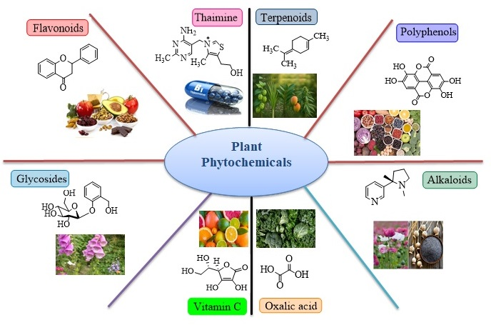
A systematic understanding of these chemical classifications is therefore essential for elucidating the mechanistic basis through which plant-derived constituents confer therapeutic effects.
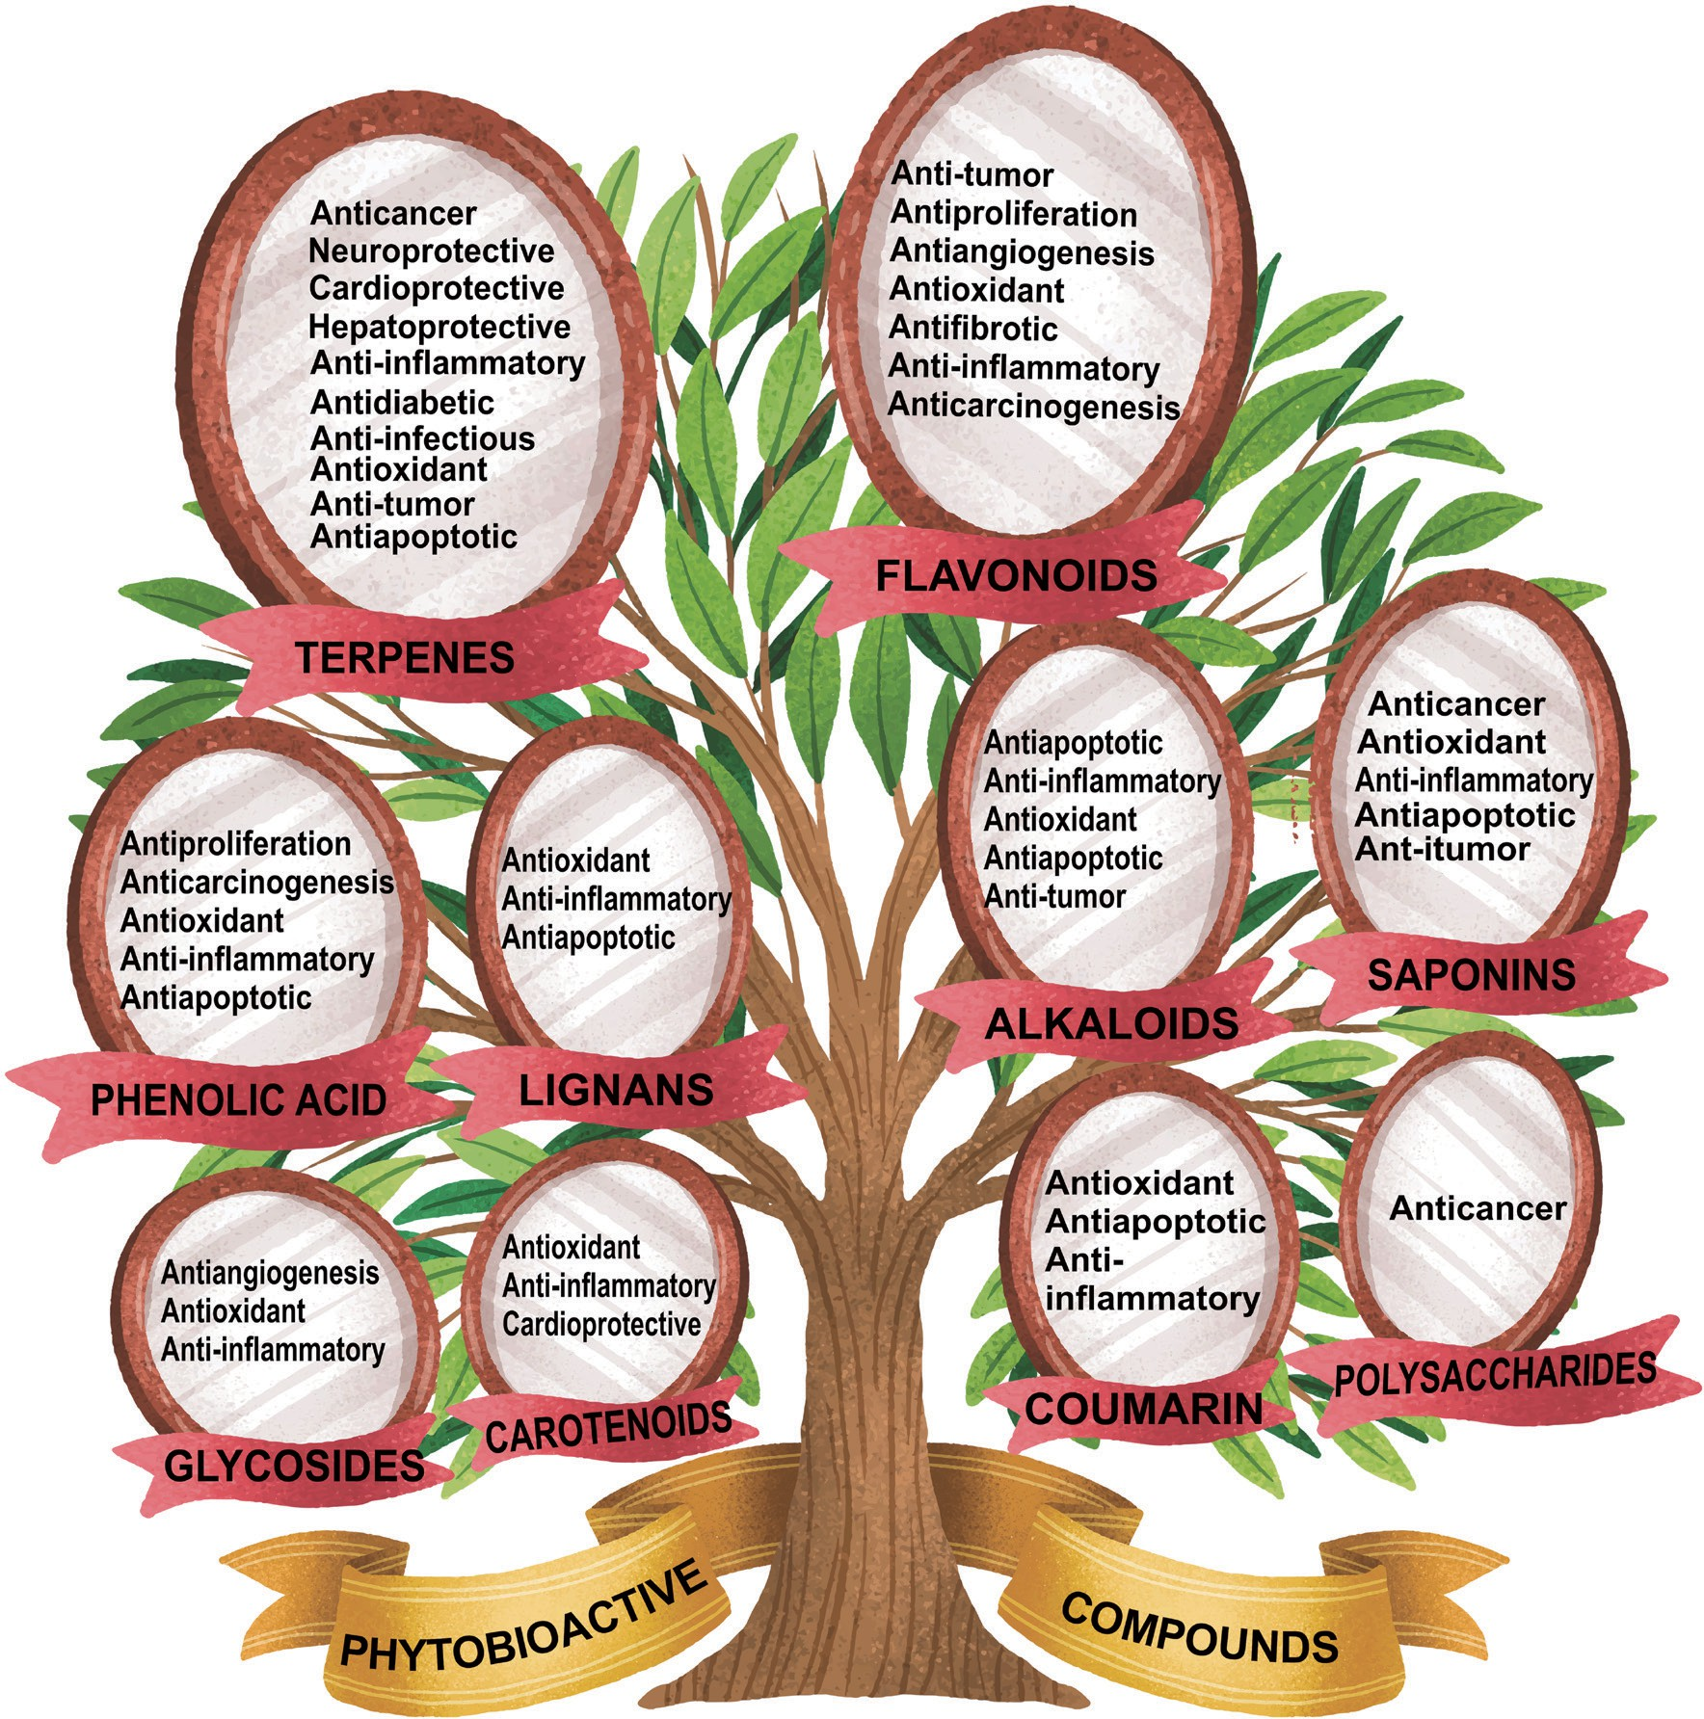
Figure 1: Overview of the classification and therapeutic potential of phytochemicals.
Alkaloids
Alkaloids are nitrogen-containing compounds often characterized by strong physiological activity. They have played a pivotal role in drug discovery; for example, reserpine, quinine, morphine, and ephedrine originated from traditional medicinal plants [13].
Mechanistically, many alkaloids function by binding receptors or modulating neuronal signaling. For example, Morphine binds opioid receptors, producing analgesia, Quinine interferes with Plasmodium metabolism, exerting antimalarial effects, Berberine regulates glucose uptake, AMP-activated protein kinase (AMPK), and gut microbiota, contributing to antidiabetic effects [5, 20]. These compounds demonstrate that alkaloids frequently act through high-affinity receptor binding, making them promising candidates in neurology, infectious diseases, and chronic metabolic disorders.
Flavonoids
Flavonoids constitute a large and structurally diverse class of phenolic secondary metabolites ubiquitously distributed in fruits, vegetables, and medicinal plants, where they play a crucial role in pigmentation and plant defence [21]. Prominent examples include quercetin, kaempferol, rutin, and anthocyanins, all of which exhibit well-documented bioactivities. The biological effects of flavonoids are mediated through multiple molecular mechanisms, including potent free radical scavenging activity, inhibition of pro-inflammatory signaling pathways such as nuclear factor kappa B (NF-κB) and mitogen-activated protein kinase (MAPK), modulation of mitochondrial-dependent apoptotic pathways, and chelation of redox-active metal ions [22]. Through the integrated regulation of oxidative stress, inflammatory cascades, and immune signaling, flavonoids have demonstrated significant therapeutic and preventive potential in cardiovascular diseases, carcinogenesis, neurodegenerative disorders, and aging-associated pathologies.
Terpenoids
Terpenoids constitute one of the most structurally diverse and biologically versatile classes of natural products, widely distributed across the plant kingdom and extensively explored for their pharmacological potential [23]. Prominent examples include artemisinin isolated from Artemisia annua, ginkgolides from Ginkgo biloba, and curcuminoids derived from Curcuma longa (turmeric). These compounds exert their biological activities through multiple mechanisms, such as disruption of parasite and bacterial survival pathways, modulation of programmed cell death and regulation of lipid metabolism and membrane-associated signaling processes. Among terpenoids, the discovery of artemisinin represents a landmark achievement in drug development; its rediscovery from ancient Chinese medical texts led to the development of an effective antimalarial therapy and this highlights the profound value of traditional medical archives in modern drug development [24].
Saponins and Glycosides
Saponins are amphiphilic glycosides characterized by their distinctive foaming properties and pronounced immunomodulatory activities, arising from their ability to interact with both aqueous and lipid environments [25]. Notable examples include gymnemic acids from Gymnema sylvestre, steroidal saponins from Panax ginseng, and cardiac glycosides such as digoxin. These compounds exert their biological effects through multiple mechanisms, including selective interaction with cholesterol-rich cellular membranes, modulation of immune responses by influencing T helper cell balance, and regulation of cardiac contractility via inhibition of the sodium–potassium ATPase, as exemplified by digoxin [26]. Owing to their capacity to regulate immune signaling and membrane-associated processes, saponins have emerged as promising therapeutic candidates for the management of chronic inflammatory conditions and metabolic syndrome.
Polysaccharides and Plant-based Peptides
Polysaccharides such as beta-glucans and mucilage from plants like aloe and mushroom species exhibit gastrointestinal, anti-inflammatory, and immune-modulating effects. Peptides from plants though less studied demonstrate antimicrobial, antihypertensive, and antioxidant properties [27].
Multi-Target Synergy
A striking feature of phytochemicals is polypharmacology, natural molecules rarely act through a single mechanism. Instead, they influence multiple cellular pathways simultaneously, restoring physiological balance rather than blocking a single biochemical target [28].
This multi-target therapeutic strategy mirrors the approach in Ayurveda and Chinese traditional medicine, where herbal formulations are tailored to address root causes of disease rather than symptoms [3].
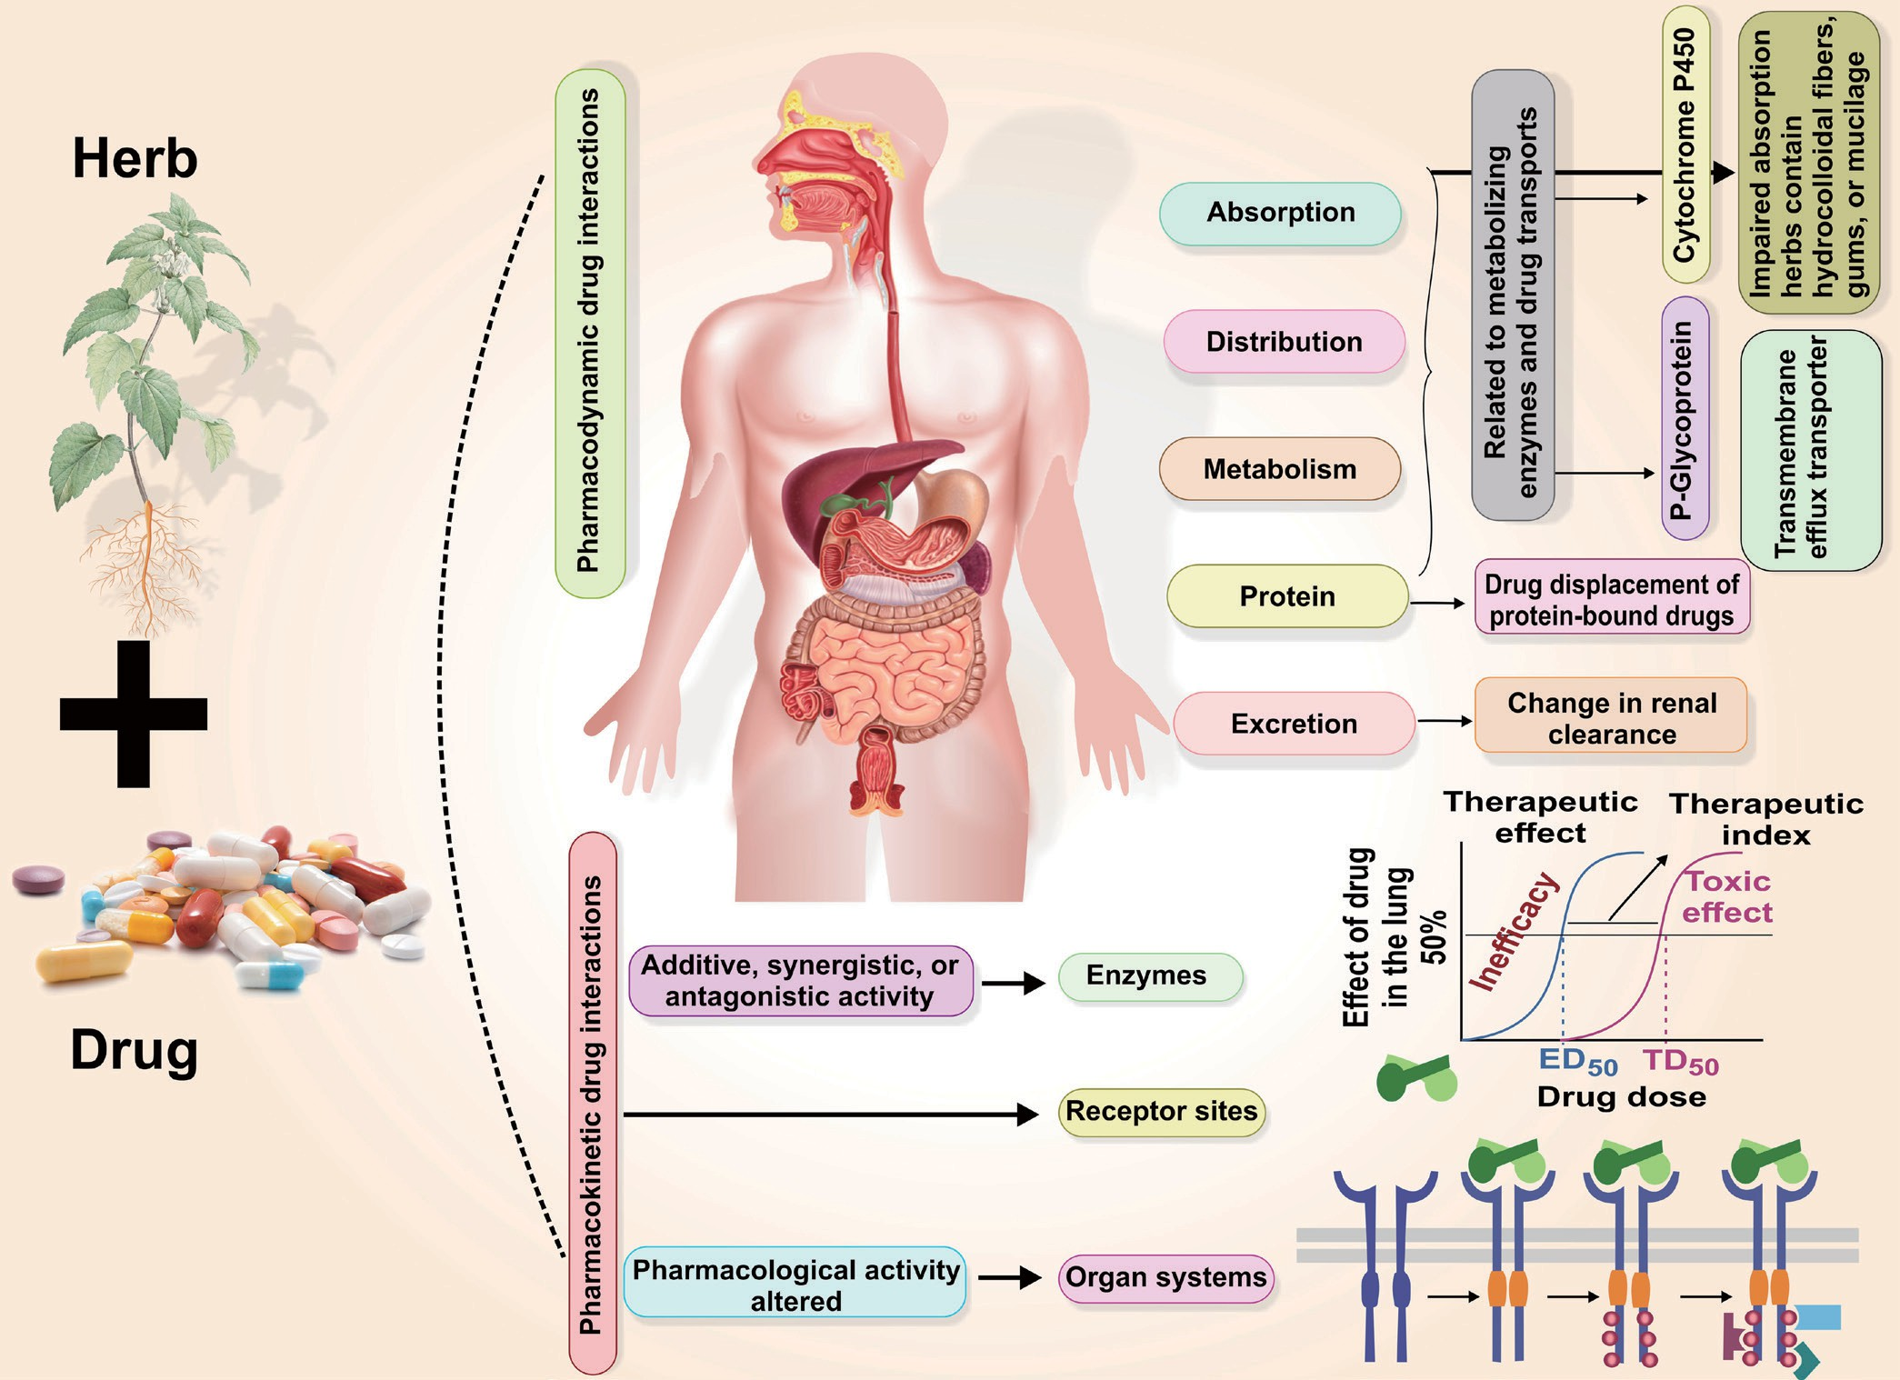
Figure 2: Pharmacokinetic and pharmacodynamic mechanistic insights of herb-drug interactions.
SAFETY, TOXICITY, AND REGULATORY LANDSCAPE
Despite increasing global enthusiasm for herbal medicine, safety considerations cannot be overlooked. The perception that “natural equals safe” is inaccurate. Toxicity may arise from overdose, improper preparation, contamination, or herb–drug interactions [29].
Toxicological Concerns
Herbal medicines are not devoid of toxicological concerns, and adverse effects may occur in acute, chronic, or carcinogenic forms [30]. Acute toxicity has been documented in cases of aconitine poisoning associated with Aconitum species, while chronic exposure, such as prolonged consumption of licorice, can result in hypertension and electrolyte disturbances. Furthermore, aristolochic acids have been unequivocally implicated in nephrotoxicity and renal carcinogenesis [31]. A substantial proportion of reported adverse events globally can be attributed to incorrect botanical identification, inadvertent substitution of toxic species for medicinal plants, and inadequate processing or storage of herbal formulations. Although traditional medical systems incorporate historical safety guidelines, their contemporary relevance necessitates rigorous re-evaluation and validation through modern toxicological methodologies and regulatory oversight to ensure safe and evidence-based clinical application.
Contamination and Adulteration
The increasing global use of herbal medicines raises contamination and adulteration due to poor-quality raw materials and finished products [32]. Studies have reported substantial regional variation in the adulteration of herbal products, with prevalence rates of 23.7% in Taiwan, 7% in California, and 1.2% in Singapore [33]. The identified forms of adulteration include the intentional addition of undeclared pharmaceutical drugs, use of synthetic steroids, and contamination with heavy metals, pesticides, and fungal toxins. These observations collectively highlight the urgent need for strengthened global regulatory oversight, rigorous authentication of herbal raw materials, and the adoption of standardized manufacturing and quality-control protocols to safeguard public health and ensure product integrity.
Regulatory Evolution
The regulation of herbal medicines has evolved significantly, guided by the World Health Organization through the introduction of Good Agricultural and Collection Practices (GACP), standardized monographs for accurate plant identification, and comprehensive quality assurance protocols. These measures aim to improve the safety, quality, efficacy, and global harmonization of herbal medicinal products. The different regional regulatory body established to maintain the quality of herbal medicines are [34]:
Region | Regulatory Body | Category
India | AYUSH Act, Pharmacopoeia Commission | Traditional Medicine
United States | FDA (Dietary Supplement Health and Education Act) | Dietary Supplement
Europe | EMA (Traditional Herbal Medicinal Products Directive) | Medicinal Product
China | National Medical Products Administration | Integrated Medicine
However, global harmonization remains an ongoing challenge.
HERB-DRUG INTERACTIONS
As more patients combine herbal remedies with prescription drugs, herb-drug interactions have become a major safety concern as less than 40% of patients disclose herbal usage to clinicians, increasing risk of adverse effects. Common herb-drug interaction pathways involve modulation of key metabolic and transport systems, including inhibition or induction of cytochrome P450 enzymes, alteration of drug efflux through P-glycoprotein transporters, and interference with coagulation pathways, which together can significantly affect drug bioavailability, efficacy, and safety e.g. few herbs-drugs interaction with potential clinical effect [35-37] listed in table:
Herb | Drug(s) | Mechanism of Interaction | Potential Clinical Effect
Ginkgo biloba | Warfarin, aspirin, clopidogrel | Platelet aggregation inhibition | Increased risk of bleeding
Garlic (Allium sativum) | Anticoagulants, antiplatelets | Antithrombotic activity | Enhanced bleeding tendency
Dong quai (Angelica sinensis) | Warfarin | Coumarin-like effects | Potentiation of anticoagulant effect
Danshen (Salvia miltiorrhiza) | Warfarin | CYP450 inhibition, antiplatelet action | Elevated INR, bleeding risk
St. John’s wort (Hypericum perforatum) | SSRIs, oral contraceptives, cyclosporine | CYP3A4 & P-gp induction | Reduced drug efficacy; serotonin syndrome (with SSRIs)
Ginseng (Panax ginseng) | Warfarin, insulin | CYP modulation, hypoglycemic effect | Reduced anticoagulation; hypoglycemia
Licorice (Glycyrrhiza glabra) | Diuretics, antihypertensives, digoxin | Mineralocorticoid-like action | Hypokalemia, hypertension
Aloe vera | Digoxin, diuretics | Electrolyte imbalance | Increased digoxin toxicity
Kava (Piper methysticum) | Benzodiazepines, CNS depressants | GABAergic potentiation | Excessive sedation, hepatotoxicity
Fenugreek (Trigonella foenum-graecum) | Antidiabetic drugs | Hypoglycemic effect | Risk of hypoglycemia
Green tea (Camellia sinensis) | Warfarin | Vitamin K content | Reduced anticoagulant effect
Peppermint (Mentha piperita) | Cyclosporine, calcium channel blockers | Inhibition of CYP3A4 enzyme | Increased plasma drug concentration, risk of toxicity
Ginger (Zingiber officinale) | Anticoagulants, antiplatelet drugs | Antiplatelet activity | Increased risk of bleeding
Thus effective clinical integration requires monitoring, dosage adjustment, and patient education.
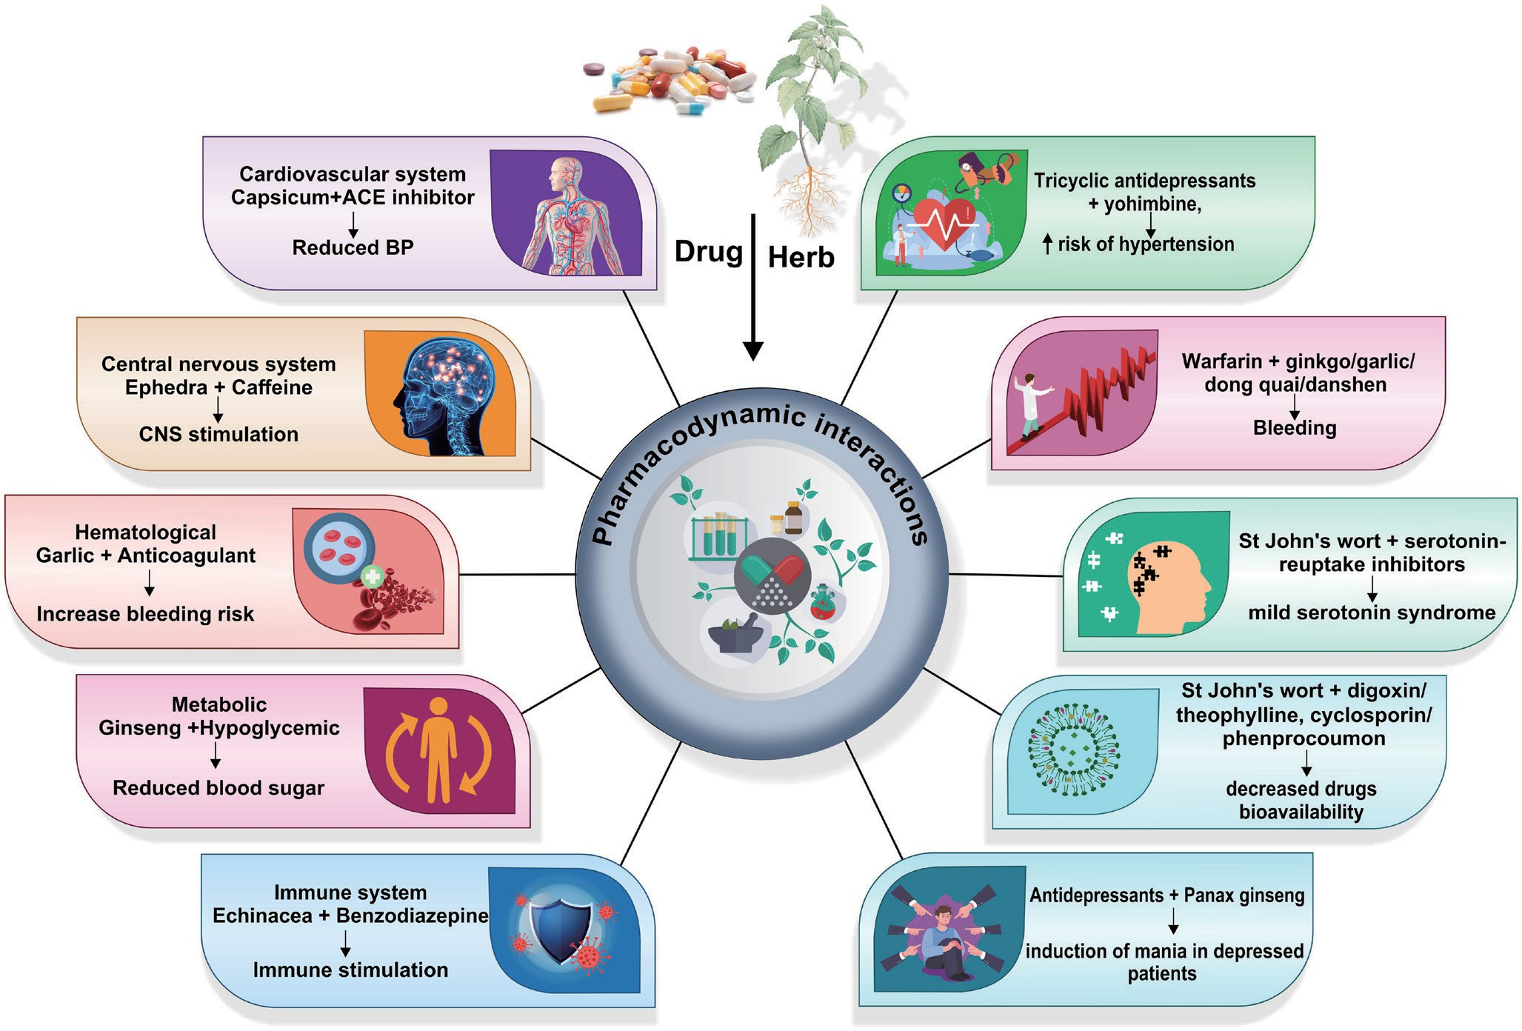
Figure 3. Impact of drug-herb interactions.
CLINICAL EVIDENCE AND CASE STUDIES
Research on natural bioactive molecules has advanced considerably due to expanding interest in their therapeutic value. Over the last two decades, randomized clinical trials, observational studies, and meta-analyses have strengthened evidence for several widely used medicinal plants [38]. Although variability in study design, dosage, extraction method, and population type remains a limitation, clinical data highlight the efficacy of herbal bioactives across multiple health domains.
Curcumin (Curcuma longa)
Curcumin is one of the most extensively studied phytochemicals due to its antioxidant, anti-inflammatory, and anticancer properties [39]. In recent study, clinical data indicate significant improvement in osteoarthritis symptoms following curcumin supplementation, demonstrating reductions in inflammatory markers such as TNF-α and IL-6. Beyond musculoskeletal disorders, curcumin has shown promising results in metabolic syndrome. A meta-analysis reported improvements in lipid profiles, insulin resistance, and oxidative stress [40]. However, poor bioavailability remains a challenge, leading to the development of formulations including nano-curcumin, liposomal encapsulation, and piperine-enhanced extracts.
Ginkgo biloba
Extracts of Ginkgo biloba contain terpenoids and flavonoids known for neuroprotective and circulatory effects. Clinical findings suggest that Ginkgo supplementation improves tinnitus and cognitive performance without severe adverse events [41]. Other trials have shown benefits in mild cognitive impairment and anxiety disorders [42]. Although results vary, Ginkgo remains one of the most widely prescribed herbal products globally, particularly in Europe and China.
Panax ginseng
Panax ginseng possesses ginsenosides believed to exert adaptogenic, anti-inflammatory, and neuroendocrine effects. Recent human clinical studies indicate that ginseng extract exhibits notable anti-fatigue effects, evidenced by enhanced physical endurance and improved regulation of hormonal balance [43]. Other studies indicate potential roles in immunity enhancement, glycemic control, erectile dysfunction, and aging-related fatigue [44].
Garlic (Allium sativum)
Garlic contains sulfur-rich molecules, including allicin and S-allyl cysteine, which exhibit antimicrobial, cardioprotective, and antioxidant properties. Clinical findings cited show garlic supplementation improves lipid levels, hypertension, and wound healing outcomes. Meta-analysis evidence also supports its role in reducing cardiovascular risk by improving endothelial function and reducing platelet aggregation [44].
POLYHERBAL AND TRADITIONAL FORMULATIONS
Many clinical investigations reflect the traditional approach of combining multiple herbs rather than isolating a single molecule. Ayurvedic formulations, TCM decoctions, and Siddha combinations have shown synergistic effects that align with modern systems biology understanding [45]. However, challenges persist regarding standardization, pharmacokinetics, reproducibility, and long-term safety evaluation.
NATURAL MOLECULES IN MODERN DRUG DISCOVERY
Plants have historically served as a foundation for drug discovery, and their relevance continues to expand with computational biology, machine learning, and high-throughput screening. The rediscovery of natural bioactive molecules represents a convergence of traditional knowledge and modern technological innovation [46].
Reverse Pharmacology and Ethnopharmacology led Research
Reverse pharmacology in herbal research begins with traditional therapeutic evidence and proceeds backward to identify mechanisms, active compounds, and molecular targets [47]. This approach reduces the time and cost involved in early-stage drug discovery. Ethnopharmacological screening has led to the discovery of blockbuster drugs including [48]:
Traditional Use | Herb/Compound | Modern Drug Class
Pain relief | Willow bark → Salicin | Aspirin (NSAID)
Malaria | Artemisia → Artemisinin | Antimalarial
Mental health | Rauwolfia serpentina → Reserpine | Antihypertensive, sedative
Cardiac therapy | Digitalis → Digoxin | Cardiac glycoside
These examples illustrate how cultural experience can inform drug design pipelines.
Omics Technologies: Genomics, Metabolomics, and Pharmacogenomics
High-resolution omics technologies are rapidly advancing natural compound research by providing comprehensive molecular insights [49]. Genomics enables the identification of biosynthetic gene clusters responsible for the production of secondary metabolites, while metabolomics allows detailed characterization of the chemical fingerprints of plant extracts. Pharmacogenomics further explains inter-individual variability in responses to phytomedicines. For example, Withania somnifera (ashwagandha) exhibits genetic chemotype variations that alter withanolide concentrations, thereby influencing its potency and therapeutic efficacy [50].
ARTIFICIAL INTELLIGENCE AND COMPUTATIONAL MODELING
AI tools such as molecular docking, QSAR modeling, and bioinformatic simulations accelerate identification of promising compounds. Machine learning can predict toxicity, target affinity, and bioavailability before laboratory experimentation [51]. This methodological evolution bridges ancient empirical knowledge with data-driven precision, improving standardization and formulation development.
FUTURE PROSPECTS AND CHALLENGES
The trajectory of natural bioactive molecule research points toward a global integration of herbal medicine into evidence-based healthcare. Yet, achieving this vision requires addressing several scientific and regulatory gaps.
PERSONALIZED HERBAL MEDICINE
As precision medicine expands, future therapeutic models may integrate genome-based individual herb selection. Traditional systems already tailor treatment to body type or prakriti-a practice now paralleled by pharmacogenomic profiling.
SUSTAINABLE SOURCING AND CONSERVATION
Growing demand threatens biodiversity. Ethical bioprospecting, sustainable cultivation, and community benefit-sharing agreements aligned with the ‘Nagoya Protocol’ are essential.
TOWARD GLOBAL HARMONIZED STANDARDS
Diverse and inconsistent regulatory frameworks continue to hinder cross-border trade in herbal products, creating challenges for quality assurance, safety, and market access [52]. Future regulatory models will need to emphasize universal quality standards, robust authentication technologies, comprehensive traceability systems, and harmonized pharmacopoeial guidelines. Emerging innovations such as DNA barcoding for species verification, blockchain-based supply chain tracking, and AI-regulated production and quality control systems offer promising tools to support regulatory convergence and enhance global confidence in herbal medicines.
CONCLUSION
Clinical evidence increasingly confirms that natural bioactive molecules possess therapeutic potential across multiple physiological systems, prompting modern drug discovery to re-embrace natural scaffolds informed by traditional medicine, ethnobotanical knowledge, and AI-assisted research. Ancient systems such as Ayurveda, Traditional Chinese Medicine, and indigenous healing traditions documented detailed botanical classifications, therapeutic uses, and preparation methods long before modern pharmacology. Today, advances in analytical chemistry, biotechnology, omics-based profiling, machine learning, nanotechnology, and evidence-based clinical studies have deepened understanding of the mechanisms underlying natural compounds. Clinical investigations of agents such as curcumin, Ginkgo biloba, Panax ginseng, and garlic demonstrate diverse antioxidant, anti-inflammatory, immunomodulatory, neuroprotective, cardioprotective, metabolic, and antimicrobial effects. However, challenges persist, including contamination, species misidentification, adulteration, limited standardization, regulatory inconsistencies, and concerns regarding herb–drug interactions, underscoring the need for collaboration among healthcare professionals and regulators. Establishing global consensus on authentication, quality control, dosage, safety monitoring, and clinical validation is essential for responsible integration. Looking ahead, precision phytomedicine supported by genomics, metabolomics, and bioinformatics, alongside sustainable cultivation and ethical bioprospecting, offers a promising pathway. Ultimately, the resurgence of natural therapeutics reflects a convergence of cultural wisdom and biomedical science, advancing holistic, inclusive, and ecologically responsible healthcare models.
REFERENCES
- Yuan H, Ma Q, Ye L, Piao G. The traditional medicine and modern medicine from natural products. Molecules. 2016;21(5): 559.
- Basu R, Dasgupta S, Babu SN, Noor A. Medicinal plants in the Indian traditional medicine and current practices. Bioprospecting of tropical medicinal plants. 2023;253-286.
- Balkrishna A, Sharma N, Srivastava D, Kukreti A, Srivastava S, Arya V. Exploring the safety, efficacy, and bioactivity of herbal medicines: bridging traditional wisdom and modern science in healthcare. Future Integrative Medicine. 2024;3(1):35-49.
- Simsek M, Whitney K. Examination of primary and secondary metabolites associated with a plant-based diet and their impact on human health. Foods. 2024;13(7):1020.
- Riaz M, Rasool N, Abbas M, Hussain H. Biological and pharmacological potential of alkaloids. Natural Product Research. 2023;37(1):78–95.
- Jordan SA, Cunningham DG, Marles RJ. Assessment of herbal medicinal products: challenges, and opportunities. Toxicological Research. 2010;26(5):159–174.
- Huang KC. The Pharmacology of Chinese Herbs. 1997;2nd edn. Boca Raton:CRC Press.
- Mardani M, Falahati M, Ashrafi K. Bioactive compounds from medicinal plants and their mechanism of action. International Journal of Herbal Med. 2013;1(4):12–22.
- Marshall AC. Traditional Chinese medicine and clinical pharmacology. In Drug discovery and evaluation: methods in clinical pharmacology, Cham: Springer International Publ. 2020;455-482.
- Qi W, He B, Gu Q, Li Y, Liang F. Scientific exploration and hypotheses concerning the meridian system in traditional Chinese medicine. Acupuncture and Herbal Med. 2024;4(3):283-289.
- Sivaji S, Thangavel S, Seetharaman B, Jayaraman L, Kaur J, Dhar SK, Mudgal G, Vasantharekha R. Synergistic Effects of Multi-Herbal and Herb–Drug Combinations and Their Molecular Mechanisms of Action and Clinical Relevance. In Exploring Herbal Synergies for Optimal Human Health. 2026;385-410.
- Vlachogianni T, Loridas S, Fiotakis K, Valavanidis A. From the Traditional Medicine to the Modern Era of Synthetic Pharmaceuticals. Pharmakeftiki. 2014;26(1):16-30.
- Newman DJ, Cragg GM. Natural products as sources of new drugs over the nearly four decades from 01/1981 to 09/2019. Journal of Natural Prod. 2021;84(3):770–803.
- Sabarudin NS, Ab Ghani N, Ahmat N, Harlin EW, Hao LQ, Handajani J, Nor FM, Md Fadilah NI, Maarof M, Fauzi MB. Harnessing Plant Bioactive Compounds in Biomaterial Scaffolds for Advanced Wound Healing: A Comprehensive Review. Biomedicines. 2025;13(10):2414.
- Joyce K, Fabra GT, Bozkurt Y, Pandit, A. Bioactive potential of natural biomaterials: Identification, retention and assessment of biological properties. Signal transduction and targeted therapy. 2021;6(1):122.
- Gureje O, Nortje G, Makanjuola V, Oladeji BD, Seedat S, Jenkins R. The role of global traditional and complementary systems of medicine in the treatment of mental health disorders. The Lancet Psychiatry. 2015;2(2):168-77.
- Lee EL, Barnes J. Prevalence of use of herbal and traditional medicines. In Pharmacovigilance for Herbal and Traditional Medicines: Advances, Challenges and International Persp. 2022;15-25.
- Dar RA, Shahnawaz M, Ahanger MA, Majid IU. Exploring the diverse bioactive compounds from medicinal plants: a review. J. Phytopharm. 2023;12(3):189-95.
- Kaur S, Samota MK, Choudhary M, Choudhary M, Pandey AK, Sharma A, Thakur J. How do plants defend themselves against pathogens-Biochemical mechanisms and genetic interventions. Physiology and Molecular Biology of Plants. 2022;(2):485-504.
- Shi R, Jin T, Xu W, Liang Y. The therapeutic potential of phytochemicals in morphine tolerance: targeting microglia-mediated neuroinflammation. Frontiers in Pharmacology. 2025;16:1669257.
- Bhatla SC, Lal MA. Secondary metabolites. In Plant physiology, development and metabolism. Springer Nature Singapore. 2023;765-808.
- Balkrishna A, Saini A, Yadav P, Yadav P, Kumar B, Arya V. New opportunities and challenges for improving the drug ability of plant products against metabolic disorders. Plant-Based Drug Discovery. 2026;91-604.
- Yang W, Chen X, Li Y, Guo S, Wang Z, Yu X. Advances in pharmacological activities of terpenoids. Natural Product Communications. 2020;15(3):1934578X20903555.
- Huang W, Wang Y, Tian W, Cui X, Tu P, Li J, Shi S, Liu X. Biosynthesis investigations of terpenoid, alkaloid, and flavonoid antimicrobial agents derived from medicinal plants. Antibiotics. 2022;11(10):1380.
- Sharma K, Kaur R, Kumar S, Saini RK, Sharma S, Pawde SV, Kumar V. Saponins: A concise review on food related aspects, applications and health implications. Food Chemistry Advances. 2023;2:100191.
- Kowsalya K, Vidya N, Halka J, Preetha JSY, Saradhadevi M, Sahayarayan JJ, Gurusaravanan P, Arun MX. Plant glycosides and glycosidases: classification, sources, and therapeutic insights in current medicine. Glycoconjugate Journal. 2026;1-18.
- Arora S, Singh D, Rajput A, Bhatia A, Kumar A, Kaur, H, Sharma P, Kaur P, Singh S, Attri S, Buttar HS. Plant-based polysaccharides and their health functions. Functional Foods in Health and Disease. 2021;11(4):179-200.
- Pham DC, Shibu MA, Mahalakshmi B, Velmurugan BK. Effects of phytochemicals on cellular signaling: reviewing their recent usage approaches. Critical reviews in food science and nutrition. 2020;60(20):3522-46.
- Chan K. Some aspects of toxic contaminants in herbal medicines. Chemosphere. 2003;52(9):1361-71.
- Mensah ML, Komlaga G, Forkuo AD, Firempong C, Anning AK, Dickson RA. Toxicity and Safety Implications of Herbal Medicines. Herb. Med. 2019;63.
- Han J, Xian Z, Zhang Y, Liu J, Liang A. Systematic overview of aristolochic acids: nephrotoxicity, carcinogenicity, and underlying mechanisms. Frontiers in Pharmacology. 2019;10:648.
- Zhang J, Wider B, Shang H, Li X, Ernst E. Quality of herbal medicines: challenges and solutions. Complementary therapies in med. 2012;20(1-2):100-106.
- Bhandari DD, Hatkar KS, Rathod SP, Kachave RR, Amrutkar SV, Shinkar DM. Exploring Herbal Remedies: Traditional Wisdom Meets Modern Science. Herbal Nanotherapy for Diabetes. 2025;52-83.
- Jain T, Dubey D, Jain V, Dashora K. Regulatory status of traditional medicines in different countries: An overview. Research J. Pharm. and Tech. 2011;4(7):1007-15.
- Izzo AA. Drug interactions with St. John’s wort (Hypericum perforatum): a review of the clinical evidence. International Journal of Clinical Pharmacology and Therapeutics. 2004;42(3):139–148.
- Cheng W, Xia K, Wu S, Li Y. Herb-drug interactions and their impact on pharmacokinetics: an update. Current drug metabolism. 2023;24(1):28-69.
- Chen XW, B Sneed K, Pan SY, Cao C, R Kanwar J, Chew H, Zhou SF. Herb-drug interactions and mechanistic and clinical considerations. Current drug metabolism. 2012;13(5):640-651.
- Jiang M, Yang J, Zhang C, Liu B, Chan K, Cao H, Lu A. Clinical studies with traditional Chinese medicine in the past decade and future research and development. Planta medica. 2010;76(17):2048-64.
- Kaur K, Al-Khazaleh AK, Bhuyan DJ, Li F, Li CG. A review of recent curcumin analogues and their antioxidant, anti-inflammatory, and anticancer activities. Antioxidants. 2024;13(9):1092.
- Panahi Y, Khalili N, Sahebi E, et al. Effects of curcuminoids on inflammation and oxidative stress in overweight and obese individuals: A randomized clinical trial. Journal of Clinical Nutrition. 2016;103(3):1–11.
- Chauhan B, Arya S, Chauhan K. Ginkgo biloba administered singly and combined with antioxidants in tinnitus patients. Journal of Audiology & Otology. 2023;27(1):37.
- Weinmann S, Roll S, Schwarzbach C. Effects of Ginkgo biloba in dementia: A systematic review and meta-analysis. The Lancet Neurology. 2010;9(9):82–89.
- Lu G, Liu Z, Wang X, Wang C. Recent advances in Panax ginseng CA Meyer as a herb for anti-fatigue: an effects and mechanisms review. Foods. 2021;10(5):1030.
- Kim JH, Yi YS, Kim MY, Cho JY. Role of ginsenosides in inflammatory responses and diseases. Journal of Ginseng Research 2018;42(4):435–443.
- Sivaji S, Thangavelu S, Seetharaman B, Jayaraman L, Kaur J, Dhar SK, Mudgal G, Vasantharekha R. Synergistic Effects of Multi-Herbal and Herb–Drug Combinations and Their Molecular Mechanisms of Action and Clinical Relevance. In Exploring Herbal Synergies for Optimal Human Health. 2026;385-410.
- Thomford NE, Senthebane DA, Rowe A, Munro D, Seele P, Maroyi A, Dzobo K. Natural products for drug discovery in the 21st century: innovations for novel drug discovery. International journal of molecular sciences. 2018;19(6):1578.
- Behrouz V, Zahroodi M, Clark CC, Mir E, Atashi N, Rivaz R. Effects of Garlic Supplementation on Cardiovascular Risk Factors in Adults: A Comprehensive Updated Systematic Review and Meta-Analysis of Randomized Controlled Trials. Nutrition reviews. 2026;84(1):1-35.
- Heinrich M. Ethnopharmacology and drug discovery. Elsevier reference module in chemistry, molecular sciences and chemical engineering. Elsevier, Waltham. 2013;1-24.
- Aborode AT, Awuah WA, Mikhailova T, Abdul-Rahman T, Pavlock S, Kundu M, Yarlagadda R, Pustake M, Correia IF, Mehmood Q, Shah P. OMICs technologies for natural compounds-based drug development. Current Topics in Medicinal Chemistry. 2022;22(21):1751-65.
- Kumar A, Husain D, Lal RK, Singh S, Singh V, Gupta AK. Genetic diversity and future prospects in Withania somnifera (L.) Dunal: an assessment based on quantitative traits in different accessions of Ashwagandha. The Nucleus. 2023;66(2):151-9.
- Cipullo S, Snapir B, Prpich G, Campo P, Coulon F. Prediction of bioavailability and toxicity of complex chemical mixtures through machine learning models. Chemosphere. 2019;215:388-95.
- Nayan S, Kolay A, Chauhan SB, Singh I. Navigating Global Regulatory Divergence in Over-the-counter Drugs: Addressing Emerging Risks and Harmonization Challenges. Current Drug Research Reviews. 2025.

AJPTR is
- Peer-reviewed
- bimonthly
- Rapid publication
Submit your manuscript at: editor@ajptr.com

