Journal home page: http://www.ajptr.com/

AMERICAN JOURNAL OF
PHARMTECH RESEARCH

Effect of Irsal-i-Alaq (Leech Therapy) in the Management of a Chronic Non-Healing Ulcer: A Case Report

Muskan Laiq ,Mohammad Shoaib*, Asia Sultana
Department of Ilaj Bit Tadbeer, Faculty of Unani Medicine, AMU, Aligarh
ABSTRACT
Chronic non-healing ulcers constitute a major global health burden and are associated with significant morbidity, psychological distress, reduced quality of life, and risk of limb amputation. Epidemiological studies indicate that approximately 1–2% of the population may develop chronic wounds during their lifetime. In India, the prevalence was reported to be 4.8 per 1,000 populations in 2004. Despite advances in conventional wound care, many cases remain refractory to treatment. Irsal-i-Alaq (leech therapy), a classical regimen of Unani medicine, may offer a complementary therapeutic approach in such cases. To evaluate the therapeutic efficacy and safety of Irsal-i-Alaq in the management of a chronic non-healing ulcer. A 45-year-old male patient presented with a six-month history of a non- healing ulcer over the lateral malleolus of the left foot, associated with pain, swelling, discharge, and skin discoloration. Leech therapy was administered weekly for two months, and the ulcer was assessed at 15-day intervals using standardized clinical parameters. Progressive improvement in ulcer size, discharge, pain, and surrounding inflammation was observed, culminating in complete healing by the end of the treatment period. No adverse events were reported. Irsal-i-Alaq demonstrated significant clinical efficacy in this case of chronic non-healing ulcer and may serve as a cost-effective adjunct or alternative therapy. Further controlled clinical studies are warranted to validate these findings.
Keywords: Irsal-i-Alaq, Chronic Ulcer, Leech Therapy, Unani Medicine, Non-healing Wound

*Corresponding Author Email: laiqmuskan@gmail.com
Received 22 January 2026, Accepted 05 February 2026

INTRODUCTION
A chronic non-healing ulcer is defined as a wound that fails to progress through the normal phases of healing within three months despite appropriate care or remains unhealed after one year¹. Chronic wounds affect approximately 1–2% of individuals in developed countries, with nearly 6.5 million patients reported in the United States alone. According to the Wound Healing Society, chronic wounds are broadly categorized into pressure ulcers, diabetic ulcers, venous ulcers, and arterial ulcers based on etiology². Lower limb ulcers are frequently encountered in clinical practice and are often characterized by persistent pain, fragile granulation tissue, malodour, tissue breakdown, and impaired epithelialization^{3,4}. Venous ulcers typically present as shallow lesions with irregular margins, surrounding hyperpigmentation, oedema, and dermatitis. Arterial ulcers, in contrast, develop rapidly due to ischemia and are often deep, painful, and located over pressure points such as the toes and heels⁵. Medicinal leech therapy (MLT) is a bio-therapeutic modality involving controlled bloodletting and the delivery of bioactive substances from leech saliva into local tissues. These secretions possess anticoagulant, vasodilatory, anti-inflammatory, and thrombolytic properties, thereby improving microcirculation and promoting tissue regeneration⁶.
In the Unani system of medicine, chronic ulcers are referred to as Quroohe Khabeesa. Classical scholars such as Rabban Tabri emphasized the role of imbalance in mizaj (temperament), particularly excessive hararat (heat) and ratubat (moisture), in the pathogenesis of suppurative conditions. Treatment principles focus on elimination of morbid humors and restoration of physiological equilibrium⁷.

Case Presentation
A 45-year-old male presented to the Outpatient Department of Ilaj Bit Tadbeer with a six- month history of a non-healing ulcer over the lateral aspect of the left foot. The lesion was associated with pain, sero-purulent discharge, oedema, and peri-lesional hyperpigmentation. The patient had previously received conventional management, including topical antiseptics, systemic antibiotics, and dressings, with only temporary symptomatic relief. There was no history of diabetes mellitus, hypertension, smoking, alcohol intake, or other comorbid conditions. General and systemic examinations were unremarkable. Vital parameters were within normal limits, and sensory examination (pain, touch, temperature, and pressure) revealed no deficits. The patient was hemodynamically stable. Written informed consent was obtained prior to initiation of therapy.

Aim and Objective
To evaluate the efficacy of Irsal-i-Alaq (Leech Therapy) in the management of a chronic non- healing ulcer

MATERIALS AND METHOD

Patient Screening
A detailed clinical history and laboratory evaluation were conducted to exclude contraindications such as anemia, bleeding disorders, and immune-compromised states. Baseline investigations included hemoglobin, bleeding time (BT), clotting time (CT), fasting and postprandial blood glucose, total leukocyte count (TLC), differential leukocyte count (DLC), erythrocyte sedimentation rate (ESR), HBsAg, and HIV screening.

Pre-procedural Preparation
Leech is very sensitive to smell and not easily attached to smelled part that is why patient is advised to take proper bath and take light diet which is free from any smell like not to eat garlic, onion, tobacco, smoking prior to therapy to facilitate leech attachment. The affected area was cleansed with sterile water and free form any smell to avoid repelling the leeches.

Procedure
Leech therapy was performed under controlled environmental conditions (Room temperature, Peaceful atmosphere, and adequate lighting) because they are very sensitive to noise, smell, excessive heat and cold. Fresh, active leeches were procured from the institutional leech bank and activated prior to application. Four to six leeches (3–4 inches in length) were applied to the on peri-ulcer area and allowed to feed for approximately 30–45 minutes until spontaneous detachment.
Post-leech therapy, the wound was dressed with sterile antiseptic thick gauze with cotton to absorb oozing blood for up to 2-48 hours. The oozing of blood removes morbid humours and increase blood and nutrient supply of the affected area that helps in wound healing. Leech therapy was applied once weekly for two months.

Outcome Measures
Clinical evaluation was conducted at baseline and at 15-day intervals for two months. Parameters assessed included:
- Ulcer size and depth
- Nature and amount of discharge
- Pain intensity
- Surrounding oedema and discoloration
- Development of granulation tissue
Haemoglobin level was monitored bi-weekly to rule out anaemia due to post leech therapy bleeding. Doppler studies were performed pre and post-treatment to evaluate vascular status. No concomitant therapies were permitted during the study period. Pictorial presentation of wound and leech therapy are given below.
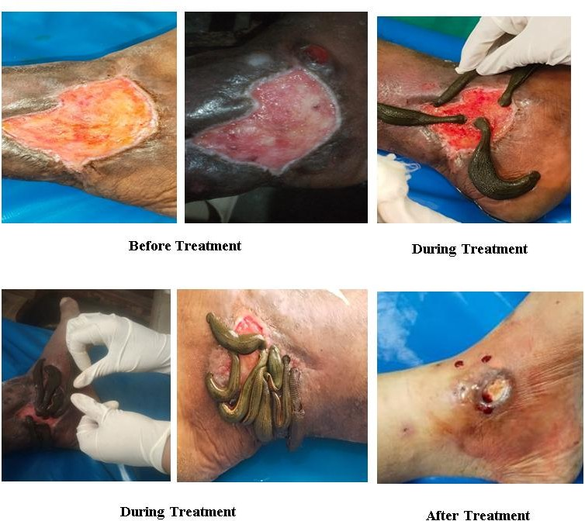

Figure 1: Pictorial presentation of wound and leech therapy

RESULTS AND DISCUSSION
Marked clinical improvement was observed over the treatment period. Gradual reduction in ulcer size, discharge, pain, and oedema was noted, with healthy granulation tissue formation and eventual complete epithelialization by the end of two months. No adverse events or recurrence were documented during follow-up.
The therapeutic effect of leech therapy can be attributed to multiple bioactive constituents in leech saliva, including hirudin, calin, bdellins, eglins, hyaluronidase, apyrase, destabilase, and acetylcholine. Hirudin and calin exert potent anticoagulant effects, reducing venous stasis which is a key contributor to chronic ulceration. Vasodilatory substances enhance microcirculation and oxygen delivery, while anti-inflammatory substances like bdellins, and eglins inhibit inflammatory process and neutrophil-mediated tissue damage. Hyaluronidase enhances membrane permeability, facilitates diffusion of fluids, and provides antimicrobial action. Destabilase provides thrombolytic activity, and apyrase prevents platelet aggregation, collectively facilitating improved wound healing⁸.
From the Unani perspective, the diversion and evacuation of morbid humors through oozing of blood of post leech therapy and injecting the cocktail of leech saliva into the host helps in clear venous stasis of blood, enhances circulation of healthy blood and nutrients, and promotes tissue regeneration. Although this case demonstrates promising outcomes, larger randomized controlled trials are necessary to establish standardized protocols and confirm efficacy.

CONCLUSION
Irsal-i-Alaq (leech therapy) demonstrated significant therapeutic benefit in this case of chronic non-healing ulcer, leading to complete wound resolution without adverse effects. The therapy appears to be safe, cost-effective, and clinically beneficial. However, systematic clinical trials with larger sample sizes are required to validate its role in chronic non healing ulcers management.

REFERENCES:
- B. Kahle, H. J. Hermanns, and G. Gallenkemper, (Evidence-based treatment of chronic leg ulcers), Deutsches Ärzteblatt International, 2011; 108(14): 231–237.
- Järbrink K, Ni G, Sönnergren H, Schmidtchen A, Pang C, Bajpai R, Car J. Prevalence and incidence of chronic wounds and related complications: a protocol for a systematic review. Syst Rev. 2016 Sep 8;5(1):152. [doi: 10.1186/s13643-016 0329-y].
- R. V. González-Consuegra and J. Verdú, (Quality of life in people with venous leg ulcers: an integrative review), Journal of Advanced Nursing, 2011; 67(5): 926–944.
- C. S. Sasanka, (Venous ulcers of the lower limb: where do we stand?) Indian Journal of Plastic Surgery, 2012; 45(2): 266–274.
- Shenoy RK. Manipal Manual of Surgery. New Delhi, India: CBS Publishers & Distributors; 2010.
- Koeppen, D., Aurich, M., Pasalar, M., & Rampp, T. (2019). Medicinal leech therapy in venous congestion and various ulcer forms: Perspectives of Western, Persian and Indian medicine. Journal of traditional and complementary medicine, 10(2), 104–109. [https://doi.org/10.1016/j.jtcme.2019.08.003]
- Ali bin Sahal Raban Tabri. Firdaus-Al-Hikmat (complete). Urdu trans- lation by Shah Shambhali. Deoband: Faisal Publications, 2002; 87.
- Andreas Michalsen, MD, Manfred Roth, PhD,Gustav Dobos, MD, Medicinal Leech Therapy, Georg Thieme Verlag, Germany, 2007, PP1- 40,134

AJPTR is
- Peer-reviewed
- bimonthly
- Rapid publication
Submit your manuscript at: editor@ajptr.com

