Journal home page: http://www.ajptr.com/

AMERICAN JOURNAL OF
PHARMTECH RESEARCH

Sub-Antimicrobial Dose Doxycycline as a Host-Modulating Agent in the Management of Periodontitis: A Comprehensive Review

Thenral Saravanabhavan, Swetha Ramakrishnan*, Vikram Saravanan, Varshini Chinraj, Deepshika Saravanan, Maria Subash Aaron Muthuraj
Department of Periodonotology and Implantology, RVS Dental College and Hospital, Coimbatore, Tamil Nadu – 641402.
ABSTRACT
Periodontitis is a chronic inflammatory disease characterized by progressive destruction of the supporting structures of the teeth, including gingiva, periodontal ligament, and alveolar bone. Although microbial plaque biofilm is considered the primary etiological factor initiating periodontal disease, the severity of tissue destruction largely depends on the host immune inflammatory response. Conventional periodontal therapy primarily focuses on mechanical removal of bacterial plaque through procedures such as scaling and root planning. However, this approach alone may not sufficiently control host-mediated inflammatory destruction. Consequently, host modulation therapy has emerged as an important adjunctive strategy in periodontal treatment. Sub-antimicrobial dose doxycycline (SDD) is currently the most extensively studied host-modulating pharmacologic agent used in periodontology. When administered at low doses that do not produce antibacterial activity, doxycycline demonstrates anti-inflammatory and anti-collagenase properties. The drug primarily inhibits matrix metalloproteinases, a group of enzymes responsible for degradation of connective tissue components in periodontal disease. In addition, SDD reduces inflammatory cytokine production, decreases osteoclast activity, and limits oxidative stress within periodontal tissues. Numerous clinical studies have demonstrated that SDD used in combination with conventional periodontal therapy results in improvements in clinical attachment level, probing pocket depth, and overall periodontal stability. This review provides a comprehensive overview of the pathogenesis of periodontitis, the principles of host modulation therapy, mechanisms of action of subantimicrobial dose doxycycline, clinical evidence supporting its therapeutic use, safety profile, limitations, and future perspectives in host-directed periodontal therapy.
Keywords: Periodontitis; Sub-antimicrobial dose doxycycline; Host modulation therapy; Matrix metalloproteinases; Periodontal inflammation; Scaling and root planning; Connective tissue degradation; Adjunctive periodontal therapy.

*Corresponding Author Email: swejanramky199@gmail.com
Received 22 February 2026, Accepted 20 March 2026

INTRODUCTION
Periodontal diseases represent a major public health concern worldwide due to their high prevalence and potential to cause tooth loss and functional impairment ^{[1]}. Periodontitis is a multifactorial inflammatory disease affecting the supporting structures of teeth and is characterized by progressive destruction of the periodontal ligament and alveolar bone^{[1]}. If untreated, the disease eventually leads to tooth mobility and loss, significantly affecting oral function and quality of life ^{[1]}. Furthermore, increasing evidence suggests that periodontal disease may influence systemic health by contributing to inflammatory conditions such as cardiovascular disease, diabetes mellitus, and adverse pregnancy ^{[2].}
The initiation of periodontal disease is closely associated with the accumulation of dental plaque biofilm composed of microbiota ^{[1]}. These microorganisms release various virulence factors including endotoxins, enzymes, and metabolic by-products that stimulate an inflammatory response in the Surrounding periodontium ^{[2]}. However, current understanding indicates that the host immune response plays a more critical role in determining the severity of tissue destruction than the direct effects of bacterial pathogens alone^{[3]}.
The host response to periodontal pathogens involves activation of immune cells such as neutrophils, macrophages, and lymphocytes^{[3]}. These cells release a wide range of inflammatory mediators including cytokines, prostaglandins, and proteolytic enzymes that contribute to tissue damage ^{[3]}. Among these mediators, matrix metalloproteinases have been identified as key enzymes responsible for the degradation of extracellular matrix components in periodontal tissues^{[3]}.
Conventional periodontal therapy focuses primarily on controlling bacterial infection through mechanical removal of plaque and calculus using procedures such as scaling and root planning^{[3]}. While these treatments are effective in reducing microbial load, they do not directly address the host mediated inflammatory pathways responsible for periodontal breakdown^{[3]}. Consequently, adjunctive therapeutic strategies that modulate host responses have been developed to enhance periodontal treatment ^{[4]}.
Host modulation therapy has gained increasing attention as a complementary approach in periodontal therapy ^{[2]}. This strategy aims to regulate the host immune response to reduce tissue destruction while maintaining the protective aspects of the inflammatory reaction ^{[3]}. Among various host modulating agents investigated, sub-antimicrobial dose doxycycline has emerged as the most widely studied and clinically accepted pharmacologic therapy^{[2]}.
Pathogenesis of Periodontitis:
The pathogenesis of periodontitis involves a complex interaction between microbial factors and host immune response ^{[2]}. Dental plaque biofilm acts as a reservoir for pathogenic bacteria that colonize the gingival sulcus and initiate an inflammatory response in Periodontal tissues^{[3]}. These microorganisms produce toxins and other virulence factors that trigger activation of the host immune response ^{[5]}.
The initial immune response involves migration of neutrophils into the gingival sulcus to eliminate bacterial pathogens. Neutrophils play a protective role by phagocytosing bacteria and releasing antimicrobial substances^{[5]}. However, persistent bacterial challenge leads to chronic inflammation and recruitment of additional immune cells including macrophages ^{[3]}.
Activated immune cells release pro-inflammatory cytokines such as interleukin-1, tumor necrosis factor-alpha^{[5]}. These cytokines amplify the inflammatory response and stimulate the production of other inflammatory mediators including prostaglandins and matrix metalloproteinases^{[4]}. These mediators collectively contribute to connective tissue degradation and bone resorption in periodontal disease^{[7]}.
Matrix metalloproteinases are a family of zinc-dependent enzymes capable of degrading extracellular matrix components such as collagen, gelatin, and ^{[4][6][7]}. In periodontal disease, increased levels of matrix metalloproteinases have been detected in gingival crevicular fluid and periodontal tissues^{[3]}. Excessive activity of these enzymes leads to breakdown of collagen fibers in the periodontal ligament and gingival connective tissue^{[5]}.
Simultaneously, inflammatory cytokines stimulate osteoclast differentiation and activation, resulting in alveolar bone resorption ^{[2]}. The combined effects of connective tissue degradation and bone resorption lead to clinical attachment loss and formation of periodontal disease ^{[6]}.
Thus, periodontal tissue destruction is largely mediated by the host inflammatory response rather than direct bacterial action ^{[7]}. This understanding has provided the basis for therapeutic approaches aimed at controlling host-mediated inflammatory processes in periodontal disease ^{[7]}.
Concept of host Modulation Therapy:
Host modulation therapy refers to the use of pharmacological agents to modify the host immune response in order to reduce tissue destruction associated with periodontal disease ^{[6]}. The goal of this therapeutic approach is to restore balance in the inflammatory process while maintaining the body’s ability to defend against microbial action ^{[7]}.
In periodontal disease, the host immune response is necessary for eliminating bacterial disease^{[6]}. However, when the inflammatory response becomes excessive or dysregulated, it contributes to destruction of connective tissue and alveolar bone ^{[7]}. Host modulation therapy attempts to control these destructive processes while preserving beneficial immune functions ^{[7]}.
Several classes of pharmacological agents have been investigated as host-modulating therapies in periodontology ^{[7]}. Non-steroidal anti-inflammatory drugs have been studied for their ability to inhibit prostaglandin synthesis and reduce inflammation ^{[7]}. Bisphosphonates have also been explored due to their capacity to inhibit osteoclast-mediated bone resorption ^{[2] [7]}.
Among these agents, tetracycline derivatives have demonstrated unique properties beyond their antimicrobial activity ^{[6]}. These compounds have the ability to inhibit matrix metalloproteinases and reduce collagen degradation ^{[7] [8]}. Doxycycline, a semi-synthetic tetracycline derivative, has been shown to possess particularly strong anti-collagenase effects ^{[8]}.
Research has shown that doxycycline can inhibit matrix metalloproteinases even at concentrations below those required for antibacterial activity ^{[7]}. This discovery led to the development of sub-antimicrobial dose doxycycline as a host-modulating therapy in periodontal disease ^{[2] [9]}.
Sub-antimicrobial dose Doxycycline:
Sub-antimicrobial dose doxycycline refers to administration of doxycycline at a dosage lower than that required to inhibit bacterial growth ^{[8][10]}. The most commonly prescribed dosage for host modulation therapy is 20 mg of doxycycline taken twice daily ^{[3][8]}.
At this low concentration, the drug does not exert significant antibacterial effects and therefore does not disturb the normal microbial flora of the oral cavity ^{[2]}. Instead, it acts primarily on host inflammatory pathways involved in periodontal tissue destruction ^{[5] [8]}.
The introduction of SDD represented a significant advancement in periodontal therapy because it allowed clinicians to utilize the anti-inflammatory properties of doxycycline without the risk of developing antibiotic resistance ^{[8]}.
Mechanism of action of SDD:
The therapeutic effects of sub-antimicrobial dose doxycycline are mainly attributed to its ability to inhibit matrix metalloproteinases ^{[4][8]}. These enzymes require metal ions such as zinc and calcium for activation ^{[3]}. Doxycycline binds to these metal ions and interferes with enzymatic activity, thereby preventing degradation of extracellular matrix components ^{[3][8]}.
In addition to inhibiting matrix metalloproteinases, doxycycline also modulates several inflammatory pathways involved in periodontal disease ^{[3][8]}. The drug reduces the production of pro-inflammatory cytokines such as interleukin-1 and tumor necrosis factor-alpha, which play a key role in tissue destruction ^{[7][8]}.
Another important mechanism involves the inhibition of osteoclast activity ^{[6]}. Osteoclasts are specialized cells responsible for bone resorption ^{[6]}. During periodontal disease, inflammatory mediators stimulate osteoclast differentiation, leading to alveolar bone loss ^{[4][8]}. Doxycycline reduces osteoclast activity and helps preserve bone structure ^{[5]}.
Furthermore, doxycycline exhibits antioxidant properties that allow it to neutralize reactive oxygen species generated during inflammation. These reactive molecules contribute to tissue damage and amplify inflammatory responses ^{[6][10]}. By reducing oxidative stress, doxycycline provides additional protection to periodontal tissues^{[5]}.
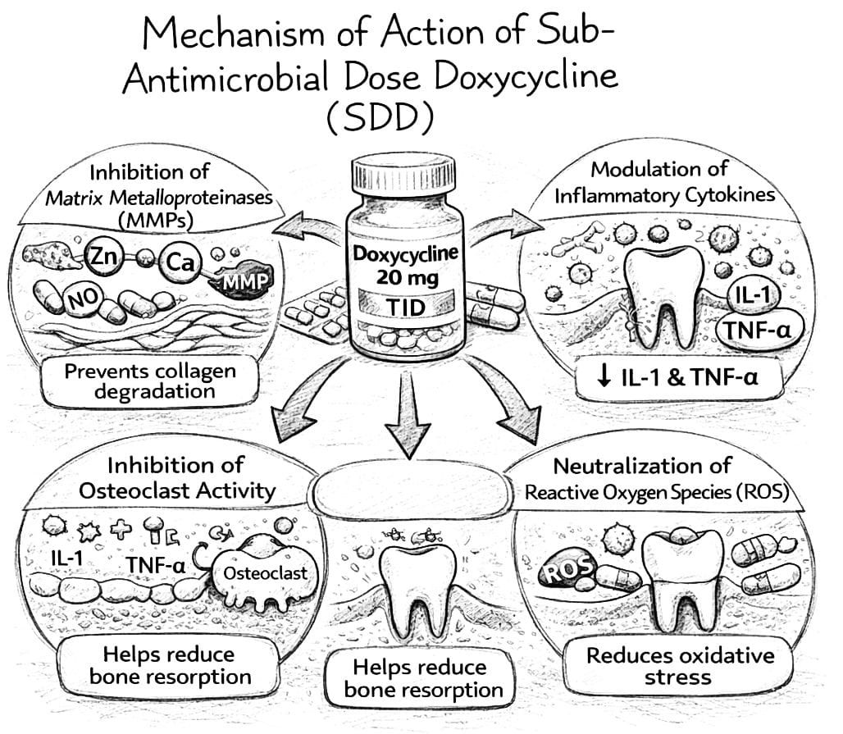
CLINICAL EVIDENCE SUPPORTING SDD:
A large number of clinical studies have evaluated the effectiveness of sub-antimicrobial dose doxycycline as an adjunct to conventional periodontal therapy ^{[4]}. These studies have consistently demonstrated improved clinical outcomes when SDD is used in combination with scaling and root planning ^{[4][6]}.
One of the most frequently reported benefits of SDD therapy is reduction in probing pocket depth ^{[4]}. Deep periodontal pockets provide an environment conducive to bacterial colonization and disease progression ^{[6]}. Adjunctive use of SDD has been shown to enhance pocket depth reduction, particularly in patients with moderate to severe periodontitis ^{[5]}.
Another significant clinical outcome associated with SDD therapy is improvement in clinical attachment level ^{[5]}. Clinical attachment gain indicates stabilization of periodontal tissues and improved healing following treatment ^{[5]}.
SDD therapy has also been shown to reduce gingival inflammation and bleeding on probing ^{[7]}. These improvements are attributed to the anti-inflammatory effects of doxycycline and its ability to suppress destructive enzymes involved in periodontal breakdown ^{[7]}.
Long-term studies have demonstrated that SDD can help maintain periodontal stability and reduce the risk of disease recurrence ^{[7]}.
Safety and Adverse Effects:
Sub-antimicrobial dose doxycycline has been shown to have an excellent safety profile ^{[8][9]}. Because the drug is administered at a dose below the antimicrobial threshold, it does not significantly affect the normal microbial flora of the oral cavity and does not contribute to antibiotic resistance ^{[9]}.
Most patients tolerate SDD well, and adverse effects are relatively uncommon ^{[7]}. When side effects occur, they are usually mild and may include gastrointestinal discomfort, headache, or mild photosensitivity ^{[6][7]}.
Clinical studies have demonstrated that long-term use of SDD is safe and well tolerated, making it suitable for extended use in periodontal therapy ^{[7]}.
Limitations:
Despite its advantages, SDD therapy has certain limitations ^{[4]}. One of the primary limitations is the requirement for patient compliance with long-term medication regimens ^{[5]}. Since the drug is typically prescribed for several months, consistent adherence to the treatment schedule is necessary for optimal results ^{[6]}.
Another limitation is that SDD cannot replace conventional periodontal therapy ^{[6]}. Mechanical plaque removal through scaling and root planning remains essential for controlling bacterial infection ^{[6]}.
Furthermore, the effectiveness of SDD may be limited in advanced cases of periodontal disease where extensive tissue destruction has already occurred ^{[7]}.
Future Perspectives:
Recent advances in periodontal research have focused on developing new host-modulating therapies aimed at improving treatment outcomes ^{[5]}. These include targeted therapies that inhibit specific inflammatory mediators involved in periodontal ^{[4] [10]}.
Stem cell-based regenerative therapies are also being investigated as potential treatments for restoring lost periodontal ^{[6] [7]}. These approaches aim to regenerate periodontal ligament, cementum, and alveolar bone using stem cells and growth factors ^{[4][9]}.
Another promising area of research involves modulation of the oral microbiome through probiotics and other biological agents ^{[7] [8]}. These strategies aim to restore microbial balance and reduce the pathogenic potential of periodontal biofilms ^{[8]}.
CONCLUSION:
Periodontitis is a complex inflammatory disease in which host immune responses play a major role in tissue destruction. Conventional periodontal therapy focuses on eliminating bacterial plaque but does not fully address the host-mediated mechanisms responsible for periodontal breakdown .
Host modulation therapy represents an important adjunctive strategy in periodontal treatment. Among the available host-modulating agents, sub-antimicrobial dose doxycycline has been extensively studied and has demonstrated significant clinical benefits.
By inhibiting matrix metalloproteinases, reducing inflammatory mediators, and protecting connective tissue structures, SDD helps improve periodontal treatment outcomes and maintain long-term periodontal stability. Its favorable safety profile and lack of antimicrobial activity make it suitable for extended use in periodontal therapy.
Future research focusing on host-directed therapies and regenerative approaches is expected to further improve the management of periodontal diseases and enhance long-term patient outcomes.
REFERENCES:
- Si-Tayeb K, Monvoisin A, Mazzocco C, Lepreux S, Decossas M, Cubel G, et al. Matrix metalloproteinase-3 is present in the cell nucleus and is involved in apoptosis. Am J Pathol. 2006;169(4):1390-1401.
- Shinwari MS, Tanwir F, Hyder PR, Bin Saeed MH. Host modulation therapeutics in periodontics: Role as an adjunctive periodontal therapy. J Coll Physicians Surg Pak. 2014;24(9):676-684.
- Sorsa T, Golub LM, Thomas JT, Leone P, Anil S, Uitto VJ. Matrix metalloproteinases in periodontal and peri-implant diseases: Contribution to their pathogenesis, diagnosis and treatment. J Periodontal Res. 2026.
- Kim SH, Seo BM, Choung PH, Lee YM. Adult stem cell therapy for periodontal disease. Int J Stem Cells. 2010;3(1):16-21.
- Preshaw PM. Host modulation therapy with anti-inflammatory agents. Periodontol 2000. 2018;76(1):131-149.
- Salbas E, Solum S. Reliability and validity of the Turkish version of the 6-item Carpal Tunnel Syndrome Symptoms Scale. Med Bull Haseki. 2023;61(5):326-331.
- Haffajee AD, Socransky SS. Regulators of tissue destruction and homeostasis as diagnostic aids in periodontology. Periodontol 2000. 2000;24:215-225.
- Messina BM, Polizzi A, Panuzzo C, Belmonte A, Anjelova A, Fuochi V, et al. Impact of periodontal host-modulation therapies on oral-gut microbiome axis in periodontitis patients with hematological diseases: A narrative review. Life. 2025;15(12):1862.
- Parthasarathy H, Aishwarya S, Jacob CA. Role of host modulation therapy in periodontal disease. Int J Pharm Sci Res. 2016;7(2):765-770.
- 10.Socransky SS, Haffajee AD. Microbial etiologic agents of destructive periodontal diseases. Periodontol 2000. 1994;5:78-111.

AJPTR is
- Peer-reviewed
- bimonthly
- Rapid publication
Submit your manuscript at: editor@ajptr.com

