Journal home page: http://www.ajptr.com/

AMERICAN JOURNAL OF
PHARMTECH RESEARCH

Obesity Challenges and Management

Aneja, KR^{1*}, Aneja Ashish ², Aneja Raman³
1.Former Prof. and Chairman, Department of Microbiology, Kurukshetra University, Kurukshetra, India – 136119
Honorary Professor & Research Advisor, Sardar Bhagwan Singh University, Dehradun (Uttarakhand)
2.Diabetologist, Resident Medical Officer cum Administrator, University Health Centre, Kurukshetra University, Kurukshetra (India).
3.Devine Complex, Sector – 3, Urban Estate Market, Kurukshetra
ABSTRACT
Obesity is a chronic, systemic, preventable multifactorial disease caused by access and/or abnormal adiposity, negatively impacting the quality of life and reducing longevity. Body mass index (weight/height) is the often-used tool to measure obesity, a person with BMI of 30 kg/m² or more is called an obese. Clinically obesity is of two types: preclinical obesity -high body fat with no disfunction or significant impairment of the body; and clinical obesity - high body fat with clear clinical manifestations such as functional limitations or organ disfunction (e.g., cardiovascular, musculoskeletal or metabolic disorder). Obesity has emerged as perhaps the most pressing public health problem of our era whose rates are rising at a fast pace, especially among the children. Currently, over 3 billion humans grapple with overweight or obesity. Lancet reports India could have more than 440 million overweight or obese people by 2050, one of the world's highest totals. No single treatment intervention can achieve weight loss goal in isolation. This global epidemic can be tackled only by unity, by teamwork, by applying four pillars: nutritional therapy, physical activity, behavioural changes, medical intervention (anti - obesity drugs and barbaric surgery). Probiotics, the living culture of bacteria (Lactobacillus gasseri, L. plantarum, Bifidobacterium species, Bacillus coagulans) are efficacious in reducing weight loss and related disorders, hence be used by obese individuals. WHO on the World Obesity Day 2026⁵⁴ emphasized that there are 8 billion reasons to act on obesity since this is a global issue affecting people of all ages and regions, and together, we can change the story of obesity? India is facing a growing epidemic of metabolic disorders: obesity and diabetes, and GLP - 1 drugs are one form of treatment. Following the expiry of semaglutide patient on 20th March 2026, over 50 Indian pharmaceutical companies have now launched generic semaglutide drugs (injectable and pills) under different trade names, at all most of the price that multinational companies sold it at, reducing the cost from 11000 to 18000 a month for a pen, to around Rs. 1200 to 4500/month, making it more affordable thus increasing access to these drugs.
Keywords: Overweight, Body mass index, Etymology, Epidemiology, Comorbidities, Treatment, Generic semaglutide drugs, Probiotics.

*Corresponding Author Email: anejakr@gmail.com
Received 22 January 2026, Accepted 05 February 2026

INTRODUCTION
Obesity is a complex, chronic relapsing disease, defined by excessive fat accumulation - typically a body mass index (BMI) of 30 kg/m² or higher - that poses serious risks to health leading to several non-infectious/noncommunicable diseases including type 2 diabetes, obstructive sleep apnea (OSA), depression, osteoarthritis, and cancer. Overweight (slightly overweight) is a condition of excessive fat deposits with a BMI of > 25 kg/m² (Haslam and James, 2005; Chiolero, 2018; WHO 2015, 2026)¹⁻⁴. Currently, 3.8 billion people are living with obesity and overweight causing 2.8 million premature deaths, globally (Lancet, 2026; WHO, 2026)^{5,4}. Obesity leads to several unwanted effects: Metabolic, mental, musculoskeletal, medical and monetary (Kalra and Kapoor, 2026)⁶. The World Health Organization (2026)⁴ states obesity as one of the defining health and equity challenges of our time, and is a matter of growing of concern, especially for children. The increasing prevalence of obesity can be attributed to various factors, including sedentary lifestyles, poor dietary choices, genetic predisposition and environmental impact (Hage et al., 2024)⁷. Obesity has been considered as one of the most detrimental chronic metabolic diseases afflicting today's human society, and is the most important public health problem facing the world today (Global Obesity Observatory, 2026)⁸.
ETYMOLOGY
The first known use of obesity in the year 1611 was circa. The noun “obesity” had its origin from the Latin word obesitas (means fatness or corpulence), derived from ob (over/around) and edere (to eat), referring to a state of excessive body fat (Merriam-Webster, 2026)⁹. The term "overweight" is an English combination of two words: "over" for excessive and "weight" referring to body mass. People are classified as obese when their BMI-a person’s weight divided by the square of the person’s height (weight/height²) – is over 30 kg/m²; and a person having BMI in the range of 25-30 kg/m² is called overweight (WHO, 2015)³. Some East Asian Countries use lower values of BMI to calculate obesity (Kanazawa et al., 2005)¹⁰. In the current scenario, overweight is a condition of excessive fat deposits and obesity is a chronic relapsing disease arising from complex interactions (WHO, 2025)¹¹.
DEFINITIONS OF OBESITY
Obesity is a chronic, systemic, preventable multifactorial disease caused by access and/or abnormal adiposity, negatively impacting the quality of life and reducing longevity. The concept of obesity has evolved with the knowledge that it is not just a response to excessive caloric intake but, rather, a problem involving interactions between genetic, environmental, behavioural, and metabolic factors. American Medical Association (AMA) in 2013 recognized obesity as a disease characterized by excessive adiposity and one that is associated with serious health hazards (Pollack, 2014; Stoner and Cornwall, 2014)^{12,13}. The most commonly used definition of obesity is based on the body mass index (BMI) measured by weight in kilograms divided by the square of height in metres (kg/m²). A person with a BMI at or above 30 kg/m² is called obese (Pollack, 2014¹²; WHO, 2015, 2024, 2025)^{4,11,14}. However, the very well-known limitation of BMI is that it does not differentiate between fat mass and lean mass, hence cannot correctly indicate body fat distribution or the health risks related to obesity. Taking all the criteria into consideration, obesity was defined as a ‘chronic syndrome’ which is multifactorial and multidimensional, characterised by abnormal percentage or distribution of adipose tissue, associated with comorbidities and complications affecting multiple organ systems, and requiring long-term management (Kalra et al., 2023)¹⁵. The Lancet Commission in 2025 defined obesity as a condition of excess adiposity, which could or could not be associated with abnormal distribution or function of adipose tissue. Obesity was further categorized into two types: the preclinical obesity – for excessive and or abnormal adiposity when the function of other tissues and organs is intact; and the clinical obesity – for chronic systemic illness caused by excess and/or abnormal adiposity and marked by altered functioning tissues, organs or the individuals as a whole. The preclinical obesity acts as a risk factor and clinical obesity a disease in itself (Lancet Diabetes Endocrinology, 2025)⁵.
WHO (2026) recognized obesity as a chronic metabolic disorder, emerging at an alarming rate globally, especially among children and increasing risk for heart disease, diabetes and various types of cancers. Obesity is a highly prevalent chronic multisystem disease associated with shortened life expectancy due to a number of adverse health outcomes.
HISTORY OF OBESITY
Obesity has origins tracing back to prehistoric Era (24000 - 35000 years ago), with evidence of obesity in figurines (Figure 1) as old as 30000 years. During the Stone Age, Middle Ages, and 17th century, overweight indicated prosperity, power, fertility, and high status. However, Hippocrates (460 BC -370 BC) described extreme obesity as a disease for the first time in the human’s history. The term "obesity" appeared in the 17th century, called circa in 1611. With the rise of industrialization, the first papers concerning adiposity and first formal medical recognition of obesity as a health issue, along with the first diet books, were published in the late 19th century. William Banting in 1863 popularized the first widely recognized weight- loss diet. The administration of pharmacological treatments and bariatric surgery were introduced in the 20th century (Balke and Nocito, 2013; Micic et al., 2025)^{16,17}. Global rise in obesity accelerated in the last 40 years between 1980 and 2022 due to sedentary lifestyle and availability of plenty of processed foods in the global markets, and has now become one of the significant metabolic syndrome posing serious health risks for youths (NCD-RisC, 2024¹⁸; WHO, 2026⁴).
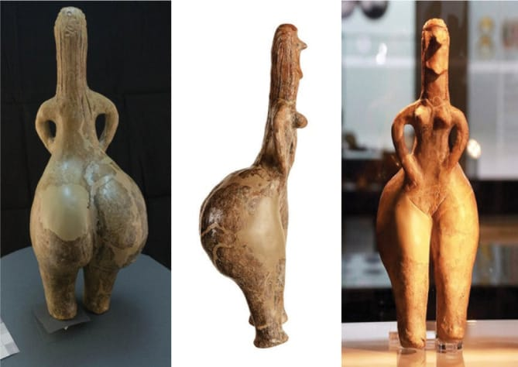
Figure 1. Red hair goddess, the National Museum, Belgrade, Serbia (Source: Micic et al., 2025).
EPIDEMIOLOGY
Obesity epidemic targeted the whole world, including developed countries and the countries in development. The disease became a great burden for society, since the number of obese people worldwide has surpassed 1 billion people (13 % of the global population) and causing 2.8 million premature deaths/year globally (NCD-RisC, 2024; WHO, 2026)^{18,4}. The number of obese and overweight people combined is projected to reach 4 billion (i.e., 25 % population) by 2035, placing more individuals at higher risks of non-infectious fatal diseases. The prevalence of obesity between 1975 and 2022 has more than tripled worldwide. The figures are alarming, especially for children and adolescents in the age group of 5-19 years, where the obesity rate increase is 10 – fold. The increase in obesity rate is most pronounced in low- and middle- income countries, including among lower socio -economic groups, where health systems often face the greatest resource constraints, is fast globalizing a problem that was once associated only with high- income countries (WHO, 2026; Global Obesity Observatory, 2026)^{4,8}.
A new Lancet study in Lancet predicted that by 2050, the total number of individuals over the age of 25 years with overweight and obesity combined, will rise to 3.80 billion globally, among which 1.95 billion would have obesity, females outnumber the males (Lancet, 4 March 2025)²¹. India is experiencing a rapid surge in obesity, facing a "double burden" of malnutrition and obesity. The number of affected Indians would be 449 million (231 million women + 218 men), nearly one-third of the population, by 2050. Obesity is more prevalent in urban areas and amongst the higher socioeconomic groups. Abdominal obesity is a major concern, especially in women in their 30s and 40s (Lancet, 2023, 2024, 2025)¹⁹⁻²¹. The global data from the Global Burden of Diseases (GPB) in 2023 by Lancet revealed that obesity in India is linked to 1 in 10 infection - related deaths, with obese individuals having a higher risk of hospitalization or death from infectious diseases (Richhariya, 2026)²².
BMI CATEGORIES
Body mass index (BMI) refers to the calculated measure of body weight relative to height used as a screening tool to estimate weight status of an individual [calculated as weight (kg)/height (m)²]. Too much or too little weight can be a health risk. BMI is just a screening tool for obesity and does not directly measure body fat percentage or muscle mass. Hence BMI to be considered with other factors when assessing an individual for health risks (CDC, 2024 a,b) ^{56,57} or clinical obesity (Rubino et al., 2025)²³. Based on CDC and WHO guidelines (WHO, 2024), BMI categories for adults (aged 20 and older) are classified into 4 types: underweight, healthy weight, overweight, and obesity (Figure 2). The four categories for adults are defined as follows:
Underweight : BMI of less than 18.5kg/m².
Healthy weight : BMI between 18.5 and 24.9 kg/ m².
Overweight : BMI between 25 and 29.9kg/ m².
Obese/obesity : BMI of 30kg/ m² or higher
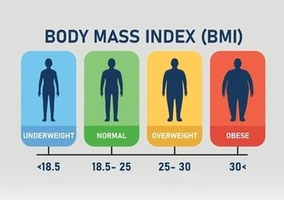 | 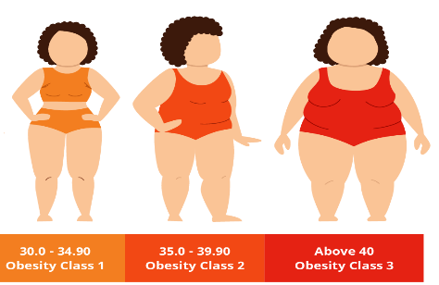 | 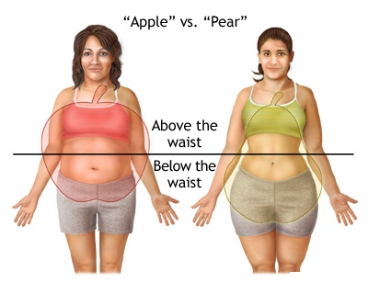
Figure 2. Classification of BMI for adults (Left), BMI-based classes of obesity (Centre) and based on fat distribution in the body (Right).
TYPES OF OBESITY
Obesity is classified into various types based on body mass index (BMI), fat distribution, and underlying causes, including primary (lifestyle), secondary (medical condition), central (abdomen), and peripheral (hips/thighs).
BASED ON BMI
Based on BMI, the WHO in 2015 classified obesity (BMI) in adults (age 18+) into three classes (Class I, Class II, and Class III) (Figure 3) to assess disease risk to be used as a tool for the appropriate treatment approach. The three classes are defined as follows:
- Obesity Class I : BMI 30.0 – 34.9 Moderate risk
- Obesity Class II: BMI 35.0 – 39.9 High risk
- Obesity Class III: BMI 40.0 or > Extremely high risk
BASED ON FAT DISTRIBUTION
- Central (Android/Apple-shaped) Obesity (Figure 2): Excess fat accumulates around the abdomen/visceral organs, increasing risks of diabetes and metabolic syndrome.
- Peripheral (Gynoid/Pear-shaped) Obesity (Figure 2): Fat is stored in the hips, thighs, and buttocks, which is more common in females.
BASED ON FAT CELL CHARACTERISTICS
- Hypertrophic Obesity: Fat cells increase in size (more common in adult-onset).
- Hyperplastic/Hypercellular Obesity: Fat cells increase in number (common in childhood-onset).
BASED ON CAUSES
- Primary/Lifestyle Obesity: Due to excessive calorie intake and sedentary behaviour.
- Secondary Obesity: Caused by underlying conditions such as hypothyroidism, Cushing's syndrome, or medications.
- Genetic/Hormonal Obesity: Related to genetic predispositions or hormone imbalances that affect metabolism.
OTHER CLASSIFICATIONS
- Sarcopenic Obesity: Combines high fat mass with low muscle mass, often seen in older adults.
- Metabolically Healthy vs. Unhealthy Obese: Classifies individuals by their metabolic health (e.g., blood pressure, blood sugar levels) rather than just weight.
OBESITY-ASSOCIATED DISEASES (COMORBIDITIES)
Obesity is a major risk factor for chronic diseases, causing over 4 million deaths annually. Excess fat cells, particularly visceral fat, cause chronic low-grade inflammation, alter metabolic processes, increase insulin resistance, and place physical stress on organs and joints. Notable obesity-associated diseases (comorbidities) (Figure 3), that increase the health risk in obese patients leading to their premature deaths. People effected by obesity or severe obesity are about 10 times more likely to have type-2 diabetes (Abdelaal et al., 2017; French, 2023; NIH-NIDDK, 2024; Bluher M, 2025; WHO, 2026)²⁴⁻²⁷. The major ones are as follows:
- Cardiovascular diseases (CVD): Hypertension, ischemic heart disease, stroke, heart failure, and atrial fibrillation.
- Endocrine/metabolic disorders: Type 2 diabetes (T2DM), insulin resistance, metabolic syndrome, and dyslipidemia (high LDL, low HDL).
- Liver disease: Metabolic dysfunction-associated steatotic liver disease (MASLD) and non-alcoholic non- alcoholic.
- Musculoskeletal disorders: Gout, degenerative joint disease, chronic back pain, and reduced physical mobility.
- Respiratory diseases: Obstructive sleep apnea (OSA) and obesity hypoventilation syndrome (Pickwickian syndrome).
- Cancers: 13 types, including endometrial, breast (post-menopausal), ovarian, prostate, liver, gallbladder, kidney, and colorectal cancer.
- Gastrointestinal disorders: Gastroesophageal reflux disease (GERD), gallbladder disease, and gallstones.
- Reproductive disorders: Polycystic ovary syndrome (PCOS), infertility, ovulatory dysfunction, and increased risk of miscarriage.
- Mental health conditions: Migraines, depression, anxiety, and low self-esteem, exacerbated by weight stigma.
- Neurological: Idiopathic intracranial hypertension.
- Stress urinary incontinence.
- Infectious diseases: Increased susceptibility to severe infections and higher risk of hospitalization from infections.
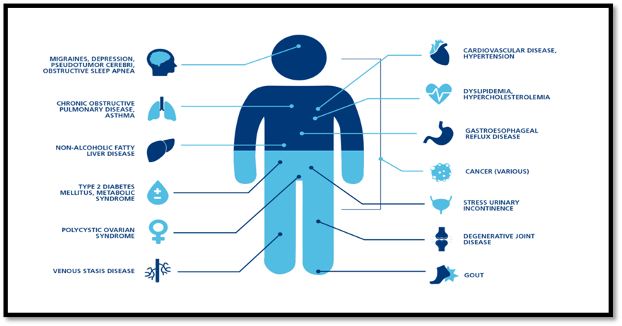
Figure 3: Comorbidities in obese individuals.
DIGNOSTIC CRITERIA FOR CLINICAL OESITY
Lancet Commission has recently proposed a new diagnostic criterion for obesity (Rubino et al., 2025). According to this framework, two key criteria must be met to establish the diagnosis of clinical obesity. To confirm access adiposity, any of the following tool can be used: once excess adiposity is confirmed through anthropometric assessment, the person should be evaluated for clinical obesity (both preclinical and clinical) based on history, physical examination, and laboratory investigations, as shown in Figure 4. An individual with no signs, symptoms or restriction in activities of daily living is regarded as having preclinical obesity. One who experiences limitations in activities of daily living is diagnosed with clinical obesity. An individual who presents with signs or symptoms of an organ dysfunction is evaluated further and diagnosed with clinical obesity if these are found to be obesity-related (Lancet Diabetes Endocrinology, 2025; Hong and Park, 2025; Rubino et al., 2025; Agarwal and Ko Ko, 2026)^{5,28,23,29}.

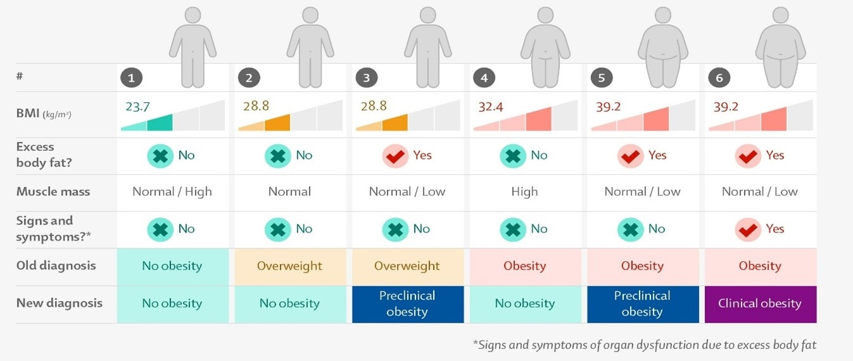
Figure 4. Traditional measurement of obesity vs new diagnostic method (Source: Lancet Diabetes Endocrinology, 2025).
MANAGEMENT OF OBESITY AND OVERWEIGHT
Obesity, a chronic multifactorial disease, is not due to excessive calories intake by a person, several other causes (Girgis 2016)³⁰ are responsible as diagrammatically shown in Figure 5. These results in early deaths in millions in obese persons, due to the occurrence of a number of serious noncommunicable diseases (NCDs), especially diabetes which occurs in over 90% of the obese individuals, hence requiring an early diagnosis and treatment.
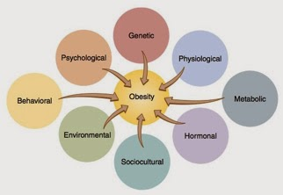
Figure 5. Causes of obesity (Source: Girgis, 2016).
The obesity treatment involves a multipronged approach starting from lifestyle interventions with guidance on diet and physical activity and behavioural therapy, to medical treatment with medications and eventually surgery in select patients, which can be achieved through a team work of different professionals (Ramaiya and Akanov, 2026; Panakajakshan and Rodriguez-Saldana, 2026; Arima, 2026)³¹⁻³³.
Kalra et al. (2021)³⁴ has suggested an obesity-friendly approach referred to an 8A approach as detailed in Figure 6 for managing obesity through a team work of professionals for the benefit of patients. This approach has been divided into two major parts-1st to attract or bring patients to the healthcare system and the 2nd to help them adhere to care. The 4A of attraction includes: awareness, availability, accessibility, and affordability, and the 4B of adherence include: attractiveness, all-inclusive treatment, assistance, and audit (Kalra et al. 2021; Ramaiya and Akanov, 2026)^{34,31}.
Figure 6. An 8A strategy for obesity-friendly system (Source: Ramaiya and Akanov, 2026).
ANTI OBESITY MEDICATIONS
The US Food & Drug Administration (FDA)⁵⁸ in 2024 approved 7 drugs (oral pills & injectable) for long-term use which are highly effective at promoting weight loss by reducing appetite or limiting fat absorption. The pills include: orlistat (Xenical, Alli), phentermine- topiramate (Qsymia) and naltrexone-bupropion (Contrave), and the drugs used as injection are liraglutide (Saxenda), semaglutide (Wegovy), tirzepatide (Zepbound) and setmelanotide (IMCIVREE) (NIH-NIDDK, 2024). The FDA approved two drugs, both launched by Eli Lilly during the recent years. These are tirzepatide (Mounjaro), an injectable drug, for managing weight loss and obesity (EMA, 2026)⁵⁵; and orforglipron (Foundayo), used as a daily oral pill to manage obesity and type 2 diabetes (Tucker, 2026)³⁵.
ORFORGLIPRON (FOUNDAYO)
Orforglipron (brand name Foundayo) is a non – peptide small molecule (GLP-1) receptor agonist, not requiring the strict fasting rules (i.e., food or water restrictions) required for other oral GLP-1 drugs. It is a recent oral daily pill (0.8mg) developed by Eli Lilly to treat obesity, type 2 diabetes and cardiometabolic conditions. This drug has been found more effective and superior for both weight loss and sugar control then it's counterpart Ozempic, a semaglutide drug (Rosenstock et al., 2026). The U.S. Food and Drug Administration (FDA) approved this drug on April 1 2026 for chronic weight management of adults (adults with obesity, or those who are overweight with at least one weight related comorbidity), especially Americans looking for convenience. Foundayo is available in oral tablets at 6 doses (0.8 mg, 2.5 mg, 5.5 mg, 9 mg, 14.5 mg, 17.2 mg), expected to be available in the USA through Lilly Direct starting April 6, 2026, with broader retail availability following shortly later (Eli Lilly, 2026; Weiser, 2026)^{38,52}. This drug will be manufactured this drug at its plant in Houston, Texas, USA starting its sale from 6th July 2026 onwards (Nair, 2026)³⁶.
This drug has several advantages over the other GLP-1 drugs (oral Ozempic and Wegovy of Novo Nordisk), that this pill can be taken at any time of day without food or water restrictions. Moreover, this drug combines unparalleled ease of administration with comprehensive, highly consistent reductions in weight (obesity), glycemia (diabetes), blood pressure, and the full spectrum of atherogenic lipids (Alper et al., 2026)³⁷. Similar to other GLP-1 medications, Eli Lilly reported that Foundayo can cause rare side effects in some patients, such as nausea, constipation, diarrhea, vomiting, indigestion, abdominal pain, headache, bloating, fatigue, and hair loss. Inflammation of the pancreas, dehydration, severe stomach problems, and allergic reactions can also occur (Eli Lilly, 2026)³⁸.
TIRZEPATIDE (MOUNJARO)
Mounjaro (tirzepatide), is an FDA approved injectable drug, manufactured by Eli Lilly. This drug is the first of its kind which is a dual acting medication targeting 2 receptor agonists namely GLP-1 (glucagon-like peptide-1) and GIP (glucose-dependant insulinotropic polypeptide) GLP-1 slows stomach emptying and signals fullness to the brain), and GIP improves the breakdown of sugar and fat. By mimicking these two natural hormones, mounjaro reduces overall calories intake and improves insulin sensitivity, making it easier for the body to lose weight, in addition to treating type 2 diabetes. Treatment strategy involves: starting dose of mounjaro 2.5 mg once weekly for 4 weeks, increasing in 2.5 mg increments to a maximum of 15 mg weekly, injected subcutaneously either into the stomach, thighs, or upper arm. The drug is available as single-dose pre-filled pens and single- patient-use KwikPens (containing 4 doses). Eli Lilly 's Mounjaro, for treating both obesity and diabetes, entered in 2025 in the Indian market.
Eli Lilly reported that the patients on mounjaro medication show the side effects including nausea, vomiting, diarrhea or constipation, heartburn or acid reflux, and injection side reactions (e.g., itchiness, redness or skin discoloration). Severe hypoglycaemia (low blood sugar) may result if used with insulin. Lifestyle changes are needed along with mounjaro medications for chronic weight management (Jastreboff et al., 2022; Lilly, 2025)^{39,40}.
Based on results from the SURPASS-PEDS trial1, the FDA has approved Mounjaro (tirzepatide) for use in children and adolescents aged 10 years and older with type 2 diabetes. The medication is indicated as an adjunct to diet and exercise to help lower hemoglobin A1c (Hannon et al., 2026)⁴¹.
SEMAGLUTIDE (OZEMPIC AND WEGOVY)
Semaglutide (known by its brand names Ozempic and Wegovy, products of Novo Nordisk, USA), a class of glucagon-like peptide-1 (GLP-1), is an injectable drug widely used globally for managing type 2 diabetes and promoting weight loss. This drug can be injected into the belly, thighs or back. The drug mimics the gut hormone GLP-1, which is released soon after eating. This hormone signals fullness to the brain, slowing digestion and stimulating the release of insulin. To overcome the problem facing the application of injectable semaglutide like low temperature storage, oral semaglutide (Rybelsus) for treating diabetes and obesity was introduced in the International market. This oral drug is taken on an empty stomach, requiring a gap of 30 minutes before eating or drinking. Clinical studies have shown that these drugs can cause minor gastrointestinal side-effects (e.g., nausea, vomiting, diarrhea, constipation) in some persons (NIH-NIDDK, 2024; Kommu and Whitfield, 2026)⁴².
In a recent registry-based study carried out on the semaglutide molecule by spanning more than a decade found surprising mental benefits, including lower risk of depression, anxiety, and reducing the burden of psychiatric illness of GLP-1 medications, even more than to manage blood sugar and weight loss (Taipale et al., 2026)⁴³.
POST-PATIENT GENERIC SEMAGLUTIDE LAUNCHES IN INDIA
On the expiry of Novo Nordisk’s core Indian patent of the semaglutide products (Ozempic®/Wegovy®) on 20th March, 2026, over 50 Indian Pharmaceutical Companies have launched or announced launching of generic versions of semaglutide (injectable pens and oral tablets) on 21st March, 2026, with prices reducing drastically from Rs. 11,000 to 18,000/month (for original brands) to as low as Rs. 1219 to 4500/ month. Some generic brands have been launched on 21st March, 2026, just after one day post expiry of the patent (Pearce, 2026)⁵³. Over 15 versions are to be launched by April 2026, with over 50 brands later in the near future (Omnicuris, 2026)⁴⁴. The key generic semaglutide brands launched recently in Indian market are as follows:
- Torrent Pharmaceuticals :SembolicTM, SemalixTM
- Dr. Reddy's Laboratories :Obeda™
- Zydus Lifesciences :Semaglyn™, Mashema™
- Alkem Laboratories :Hepaglide, Obesema
- Sun Pharma :Noveltreat, Sematrinity
- Lupin :Semanext, Livarise
- Natco Pharma :Semafull
- Glenmark Pharmaceuticals : Glipiq
- Mankind Pharma :Samakind
PROBIOTICS IN OBESITY MANAGEMENT
Probiotics (Gr.pro =life +bios=life, meaning "for life") are live microorganisms- typically bacteria and yeasts, that brings health benefits for the host, when consumed in adequate amounts, particularly by improving intestinal microbial balance. Live probiotic microbes are part of fermented dairy & vegetable products, and probiotic- fortified foods (Aneja, 2025)⁴⁵. Probiotics are the backbone of good health as they provide digestive support; promotes the growth of good bacteria in the gut; alleviates IBS symptoms such as bloating, gas, acidity and irregular bowel movements; and supports skin health, brain health (Näck, 2026)⁴⁶. Supplementation of probiotics has led to a clinically meaningful reduction in bodyweight, BMI, and waist circumstance. The best results are often seen in studies that are longer than 12 weeks and use higher dosages of probiotics. Not all probiotics are effective for obesity: only specific strains of bacteria (e.g., Lactobacillus gasseri SBT 2055, Lactobacillus plantarum, Bifidobacterium species) have shown positive outcomes in human trials. Studies carried out by various workers have shown that probiotics aid in weight management for obese individuals by altering gut microbiota, reducing fat storage and regulating metabolism. They increase appetite-regulating hormones (GLP-1, PYY), reduce energy absorption, and also combat obesity-related inflammation. Probiotics are advantageous dietary components in managing obesity and related disorders (Wicindki et al., 2020; Musazadeh et al., 2022; Nicolas et al., 2024; Niloufar et al., 2024; Sadeghi et al., 2024; Riveros et al., 2024)⁴⁷⁻⁵¹.
Näck (2026)⁴⁶ has recently patented, clinically proven probiotic, LactoSpore®, based on the bacterial strain of Bacillus coagulans MTCC 5856, an effective and safe probiotic to support your gut health. B. coagulans is a transient probiotic, meaning it does its job without overstaying its welcome. Unlike traditional probiotics based on live bacteria which often ‘dies’ in transit before reaching the gut, endospore – farming bacilli can survive stomach acid and arrive safe and sound to your intestines where it gets activated to fuel the good bacteria in your gut and support the microbiome. It's gradually excreted after discontinuation, ensuring no risk of overgrowth or negative effects. This makes LactoSpore® perfect for periodic use to boost gut health. This endospore-based probiotic specifically produces the L (+) optical isomer of lactic acid. This form of lactic acid is effective in lowering the pH of the environment, which helps prevent the growth of bad bacteria and allows good bacteria to dominate the gut flora. Dietary ingestion of lactic acid-producing bacteria has a substantial history of use, and the safety record is excellent (Aneja, 2025; Näck, 2026)^{45,46}.
CONCLUSION
Obesity refers to an abnormal or excessive fat accumulation (BMI ≥30kg/m²) is a preventable, chronic metabolic disorder that develops when the body consumes more calories than the amount it burns. Obesity, a global epidemic, reduces health longevity and overall quality of life. The prevalence of obese and overweight people is on the rise worldwide at an alarming rate, especially in adolescents, making obesity a major public health concern today. Understanding the consequences of obesity, World Obesity Federation, celebrates Global Obesity Day on 4th March every year, to awaken the people of all ages, especially youth about the risks and significance of physical activity and diet to prevent obesity and overweight for leading a good quality, healthier and longer future life. Hence, prevention and management of obesity and overweight is extremely important, which can be achieved through a multidisciplinary approach involving lifestyle modifications (low-fat and low - carbohydrate diet, exercise, walking), behavioural therapy, pharmacotherapy through weight loss drugs, and barbaric surgery. Supplementation of probiotics has led to a clinically meaningful reduction in bodyweight, BMI, and waist circumstance, and be used by obese individuals to reduce the impact of anti-obesity drugs and promoting the gut microbiome for increasing immunity.
ACKNOWLEDGEMENT
The senior author, Prof. K.R. Aneja is extremely grateful to the Universe Earth for whispering the idea and giving strength to write this article for the humanity facing the greatest epidemic of this century.
REFERENCES
- Haslam DW, James WP (2005). "Obesity". Lancet (Review). 366 (9492):1197–1209.
- Chiolero A (2018). "Why causality, and not prediction, should guide obesity prevention policy". The Lancet. October, 2018 Public Health. 3 (10): e461–e462.
- World Health Organization (2015). Obesity and overweight WHO Media Centre, Fact sheet. N°311 (Sarean). January 2015.
- World Health Organization (2026). Obesity. 27th January, 2026.
- Lancet Diabetes Endocrinology (2025). Redefining obesity: advancing care for better lives. Lancet Diabetes Endocrinol. 13(2): 75.doi. 10.1016/S2213-8587(25) 00004-X.
- Kalra S and Kapoor N (2026) (Eds). Preface. Pp v. Textbook of Obesity: Person Centered Management. IJCP Academy of CME, New Delhi
- Hage K, Perrotta G, Betancourt R S, Danaf J, Gajjar A, Tomey T, Marrero K and Ghanem O M (2024). Future prospects of metabolic and bariatric surgery: A comprehensive review. Healthcare (Basel). 26;12(17):1707.
- Global Obesity Observatory (2026). Overview. Obesity prevalence. Trends over time. Economic impact.
- Merriam-Webster (2026). “Obesity”. Merriam-Webster.com Dictionary. https://www.merriam-webster.com/dictionary/obesity. Accessed 10 April.2026.
- Kanazawa M, Yoshiike N, Osaka T, Numba Y, Zimmet P, Inoue S (2005). "Criteria and Classification of Obesity in Japan and Asia-Oceania". Nutrition and Fitness: Obesity, the Metabolic Syndrome, Cardiovascular Disease, and Cancer. World Review of Nutrition and Dietetics. 94:1–12.
- World Health Organization (2025). Obesity and overweight. 8th December, 2025.
- Pollack A (2014). A.M.A. Recognizes obesity as a disease. 2013 cited 2014 Nov 20. Available from: http://www.nytimes.com/2013/06/19/ business/ama-recognizes-obesity-as-a-disease.html.
- Stoner L and Cornwall J (2014). Did the American Medical Association make the correct decision classifying obesity as a disease? AMJ 7(11):462–464.
- World Health Organization (2024). Malnutrition. 1 March 2024.
- Kalra S, Kapoor N, and Verma M et al. (2023). Defining and diagnosing obesity in India: a call for advocacy and action. J. Obes. 2023:4178121.
- Balke H and Nocito A (2013). Vom Schonheitsideal zur Krankheit-eine Reise durch die Geschichte der Adipositas [A trip through the history of obesity]. Praxis (Bern 1994).2013Jan16;102(2):77-83.
- Micic D, Polovina S, Micic D and Yumuk YD (2025). Short history of obesity. Acta Endocrinol (Buchar). 20(2):207–211. doi: 10.4183 /aeb.2024.207.
- NCD Risk Factor Collaboration (NCD-RisC) (2024). Worldwide trends in underweight and obesity from 1990 to 2022: a pooled analysis of 3663 population-representative studies with 222 million children, adolescents, and adults. Lancet.403:1027–1050. doi: 10.1016/S0140-6736(23)02750-2.
- The Lancet (2023). Abdominal obesity in India: analysis of the National Family Health. 12 May 2023.
- The Lancet (2024). Worldwide trends in underweight and obesity from 1990 to 2022. 29 Feb. 2024.
- The Lancet (2025). A forecasting study for the Global Burden of Disease Study 2021. 3 March 2025.
- Richhariya S (2026). Lancet study links obesity to 1 in 10 infection deaths globally. What it means for India? ThePrint.10 February, 2026.
- Rubino F, Cummings DE, Eckel RH, et al. (2025). Definition and diagnostic criteria of clinical obesity. Lancet Diabetes Endocrinol. 13(3):221-62. Erratum in: Lancet Diabetes Endocrinol. 2025;13(3):e6.
- Abdelaal M, le Roux CW, Cocherty NG (2017). Morbidity and mortality associated with obesity. Ann Transl Med. 5(7):161. doi: 10.21037/atm.2017.03.107
- French M (2023). What are the effects of obesity? Reviewed by A M Bell. Medical News Today. April 27, 2023.
- NIH -NIDDK (2024). Prescription medications to treat overweight & obesity. National Institute of Diabetes and Digestive and Kidney Diseases (NIDDK), part of the National Institute of Health (NIH).
- Bluher M (2025). An Overview of obesity- related complications: The epidemiological evidence linking body weight and other markers of obesity to adverse health outcomes. Diabetes, Obesity and Metabolism. 27(S2): 3-19.
- Hong S, and Park C – Y (2025). From old to new: A comprehensive review of obesity diagnostic criteria and their implications. Endocrinology and Metabolism. 40(4):517-522.
- Agarwal K and Ko Ko U (2026). Description and diagnosis of obesity. Pp 3-10. In Textbook of Obesity: Person Centered Management. Eds S Kalra and N Kapoor. IJCP Academy of CME, New Delhi.
- Girgis L (2016). Causes of obesity: it is not just the calories. Medical information. March 12, 2016. drlinda-md.com/2016.
- Ramaiya K and Akanov Z A (2026). Teamwork. Pp 149-152. In Textbook of Obesity: Person Centered Management. Eds S Kalra and N Kapoor. IJCP Academy of CME, New Delhi.
- Pankajajkshan A and Rodriguez-Saldana J (2026). Troubleshooting. Pp 159-164. In Textbook of Obesity: Person Centered Management. Eds S Kalra and N Kapoor. IJCP Academy of CME, New Delhi.
- Arima H (2026). Foreword. viii. Textbook of Obesity: Person Centered Management. Eds S Kalra and N Kapoor. IJCP Academy of CME, New Delhi.
- Kalra S, Arora S, Kapoor N (2021). Obesity-friendly health care services - A pragmatic approach. J Pak Med Assoc. 71(11):2676-7.
- Tucker ME (2026). FDA okays orforglipron for weight management. Medscape-April 01, 2026.
- Nair J (2026). Eli Lilly's S 6.5 B Houston plant will make its new FDA-approved GLP-1 weight loss drug. Houston Business Journal. April 6, 2026.
- Alper A, Peleg G, Fagin A, Shah P, Chowdhury I, Gonzales A and Faillace R (2026). Efficacy and safety of orforglipron, an oral small-molecule GLP-1 receptor agonist, on cardiometabolic outcomes: a meta-analysis and systematic review. Cardiovasc Diabetol Endocrinol Rep. 2026 Feb 20; 12:9. doi: 10.1186/s40842-025-00270-4.
- Eli Lilly (2026). FDA approves Lilly's Foundayo™ (orforglipron), the only GLP-1 pill for weight loss that can be taken any time of day without food or water restrictions. Lilly April 1, 2026. CMAT-04552 04/2026 ©Lilly USA, LLC 2026.
- Jastreboff A M, Aronne, Ahmad N N, Wharton S et al. (2022). Tirzepatide once weekly for the treatment of obesity. N Engl J Med. 387(3):205-2016.
- Lilly (2025). Mounjaro® (tirzepatide) Injection: The First and Only GIP and GLP-1 Receptor Agonist Approved for Type 2 Diabetes.
- Hannon, Tamara S et al. (2026). New meds and tech: Mounjaro (tirepatide) approved in pediatrics. PES. February 24, 2026.
- Kommu S and Whitfield P (2026). Semaglutide. StatPearls Publishing. National Cener for Biotechnology Information (NCBI). US National Institute of Health.
- Taipale H, Taylor M, Lähteenvuo M, Mittendorfer-Rutz E, Tanskanen A and Tiihonen J (2026). Association between GLP-1 receptor agonist use and worsening mental illness in people with depression and anxiety in Sweden: a national cohort study, The Lancet Psychiatry. April 2026.
- Omnicuris (2026). Generic semaglutide in India: Lower costs for weight loss. April 10, 2026.
- Aneja KR (2025). Modern Food Microbiology. 2nd Edition. MedTech Science Press- A Division of Scientific International, New Delhi.
- Näck (2026). Probiotics. https://nack.life › products › probiotic.
- Wiciński M, Gębalski J, Gołębiewski J and Malinowski B (2020). Probiotics for the treatment of overweight and obesity in humans—A review of clinical trials. Microorganisms. 29;8(8):1148. doi: 10.3390/microorganisms8081148.
- Musazadeh V, Zarezadeh M, Ghalichi F, Ahrabi SS, Jamilian P, Jamilian P and Ghoreishi Z (2022). Anti-obesity properties of probiotics; a considerable medical intervention: Findings from an umbrella meta- analysis. European Journal of Pharmacology. Volume 928, 5 August 2022, 175069.
- Nicolás F H R, Lady G-C, Miguel A M-S, Angélica G-C (2024). Meta-analysis effect of Bifidobacterium intake on body weight and body fat in overweight and obese adult subjects: A Systematic Review and Meta-Analysis. J. Am. Nutr. Assoc. 43(6):519-531.
- Niloufar R, Mohammadreza H, Fataneh E, Sepehr K, Maryam B, Ozra Tabatabaei-M, Solaleh E (2024). The effects of prebiotic, probiotic or symbiotic supplementation on overweight/obesity indicators: an umbrella review of the trials' meta-analyses. Front Endocrinol (Lausanne).20:15:1277921.doi:10.3389/fendo.2024.1277921. eCollection 2024.
- Sadeghi A, Daroudi R, Davari M, Gharib-Naseri Z, Jafarzadeh J and Tajvar M (2024). Probiotics Antimicrob Proteins. 16(6): 2316- 2328.
- Weiser P (2026). Foundayo (Orforglipron) – Uses, side effects, and more. WebMD. April 02, 2026.
- Pearce IP (2026). Generic semaglutide launches in India, including by Dr. Reddy’s, Zydus, Alkem, Sun Pharma & Glenmark. March 21, 2026.
- World Obesity Day (2026). 8 Billion Reasons to Act on Obesity. March 4, 2026.
- EMA - European Medicines Agency (2026). Mounjaro - Meating highlights from the committee for medicinal products for human use (CHMP). 26-29 January, 2026.
- Centers for Disease Control and Prevention (2024A). BMI: Adult BMI categories. For Everyone. March 19, 2024.
- Centers for Disease Control and Prevention (2024B). BMI: Adult BMI calculator. For Everyone. June 26, 2024.
- US Department of Health and Human Services. Last reviewed June 2024.

AJPTR is
- Peer-reviewed
- bimonthly
- Rapid publication
Submit your manuscript at: editor@ajptr.com

